VIETNAM NATIONAL UNIVERSITY

**HANOI SCHOOL OF BUSINESS AND MANAGEMENT**

**----------------o0o---------------**



**LE VIET DUNG**

**Developing e-commerce website selling sports equipment for DungSport store**

Course:

**Supervisor:**

**Hà Nội, 2025**

**COMMITMENT**

I hereby declare that the content of this Project has not been submitted to any bachelor's degree program or any other degree program.

I also declare that this thesis is my personal effort. The results, analyzes and conclusions in this project (other than those cited) are the result of my own work.

*Hanoi, 03 June, 2025*

**Students perform**

**Nguyen Viet Dung**

**ACKNOWLEDGEMENT**

I am pleased to present the results of my research on "Developing an E-commerce Website Selling Sports Equipment for DungSport Store." This project represents a significant milestone in my academic and professional journey, and its successful completion would not have been possible without the support and guidance of many individuals and organizations.

First and foremost, I would like to express my deepest gratitude to my project advisor, MSc. XXXX, for her invaluable support, expertise, and mentorship. Her insightful guidance and constructive feedback have been instrumental in shaping the direction and focus of this project.

I am also grateful to the faculty and staff of the Hanoi School of Business and Management (HSB) for providing an enriching academic environment that has fostered my intellectual growth and learning. The knowledge and skills I have acquired during my time at HSB have been crucial in undertaking and completing this project.

A special thank you goes to the management and staff of DungSport Store for their cooperation and for providing me with the necessary data and insights to develop this e-commerce website. Their collaboration was vital to the project's success.

In conclusion, I am deeply thankful to everyone who has played a role in the completion of this project. Your support and encouragement have been invaluable, and I sincerely appreciate your contributions.

Thank you sincerely!

*Hanoi, 03 June, 2025*

**Supervisor Students perform**

**Vuong Thi Nhung**   **Nguyen Viet Dung**

**TABLE OF CONTENT**

**COMMITMENT** i

**TABLE OF CONTENT** iv

LIST OF ABBREVIATION vi

LIST OF TABLES vii

**LIST OF FIGURES** viii

CHAPTER 1. INTRODUCTION 1

1.1 Problem Statement 1

1.2 Project objective and mission 3

***1.2.1 Research objective*** 3

***1.2.2 Research mission*** 3

1.3 Project Scope and Subjects 3

1.4. Project Methodology 4

1.5 Project Deliverables 5

1. 6. Structure 5

**CHAPTER 2: SYSTEM ANALYSIS AND DESIGN** 6

**2.1. System Requirements Analysis** 6

***2.1.1*** ***Functional Requirements*** 6

***2.1.2. Non-Functional Requirements*** 7

***2.1.3 System Users*** 9

2.2. Use Case Analysis and Design 10

***2.2.1 Overview of Use Case Diagram*** 10

***2.2.2 Use Case Decomposition Diagram of Portfolio Management*** 11

2.3. Database Design 12

**2.3.1. Entity-Relationship Diagram (ERD)** 12

**2.3.2. Table Descriptions and Relationships** 12

**2.4 Technology used** 17

**2.5. Financial Management** 17

**2.6.Feasibility Assessment** 19

**CHAPTER 3: SOLUTION AND IMPLEMENTATION** 20

**3.1. Implementation** 20

**3.2. Functions** 22

***3.2.1. User Functions*** 22

***3.2.2. System analysis*** 23

***3.2.2.1 Web structure*** 24

***2.2.2 Customer Functionality Diagram*** 27

***3.2.2.4 Staff Function Diagram*** 35

***3.2.2.5.Sell Functionality Diagram*** 38

**3.3.Interface** 41

***3.3.1.Admin Interface*** 41

***3.3.1.1.Search and Edit customer*** 42

***3.3.1.2. Update goods*** 43

***3.3.1.3. Customers feedback*** 43

***3.3.2 Customer Interface*** 44

***3.3.2.1.View product information*** 46

***3.3.2.2.Choose goods*** 46

***3.3.2.3.Search goods*** 47

***3.3.2.4.Payment*** 47

**CHAPTER 4: CONCLUSION** 48

REFERENCES 49

APPENDIX 50

# LIST OF ABBREVIATION

|  |  |
| --- | --- |
| **Terms** | **Explain** |
| E-commerce | Electronic commerce |
| HSB | Hanoi School of Business and Management |
| VECOM | Vietnam E-commerce Association |
| SBV | State Bank of Vietnam |
| SEO | Search Engine Optimization |
| SEO | Search Engine Optimization |
| CSS | Cascading Style Sheets |
| PHP | Personal Home Page |
| SSD | Solid State Drives |
| HDD | Hard Disk Drives |
| 3PLs | Third-party logistics providers |

# LIST OF TABLES

*Table 3. 1: Site Map (Source: Author)* 39

Table 3. 2: Customer Functionality Diagram (Source: Author) 42

Table 3. 3: Admin Functionality Diagram (Source: Author) 48

Table 3. 4: Staff Function Diagram (Source: Author) 50

Table 3. 5: Sell Functionality Diagram (Source: Author) 53

Graph 2. 1: *Use case diagrams (Source: Meeraacademy.com)* 22

**LIST OF FIGURES**

*Figure 3. 1: Admin interface (Source: Author)* 56

Figure 3. 2: Search and Edit customer (Source: Author) 57

*Figure 3. 3: Update goods (Source: Author)* 58

*Figure 3. 4: Customers feedback (Source: Author)* 58

*Figure 3. 5: Customer Interface (Source: Author)* 59

*Figure 3. 6: View product information (Source: Author)* 61

*Figure 3. 7: Choose goods (Source: Author)* 61

Figure 3. 8: Search goods (Source: Author) 62

*Figure 3. 9: Payment (Source: Author)* 62

# 

# CHAPTER 1. INTRODUCTION

## 1.1 Problem Statement

The gradual decline in the competitive edge and revenue of traditional small retail stores, coupled with the increasing trend of consumers opting for online shopping instead of visiting physical outlets, can be largely attributed to the pervasive impact of e-commerce platforms. E-commerce, short for electronic commerce, covers a wide range of online transactions, from retail sales and electronic payments to auctions and internet banking. This mode of commerce has transformed the business landscape by enabling transactions anytime and anywhere without physical interaction, thereby offering unparalleled convenience, efficiency, and global connectivity.

This shift in consumer behavior is driven by several interconnected factors, supported by empirical data and market trends. First, Vietnam’s rapid economic growth and technological advancements have created a fertile ground for the expansion of e-commerce. With the rising number of internet users and widespread smartphone adoption, consumers are increasingly empowered to shop online. For instance, reports from the Vietnam E-commerce Association (VECOM) have highlighted a significant rise in internet usage, contributing to an environment where e-commerce services continue to evolve and expand.

Second, the evolution and broader adoption of online payment systems have been crucial in ensuring secure and seamless transactions. The integration of various payment methods such as credit cards, e-wallets, and online transfers has not only simplified the payment process but also boosted consumer confidence in online shopping. Data from financial institutions like the State Bank of Vietnam reflect a marked increase in the volume and value of online transactions, underscoring this trend.

Moreover, the improvement in logistics and delivery services plays a vital role in sustaining the growth of e-commerce. E-commerce platforms have strategically invested in enhancing their supply chain and delivery networks to ensure timely and efficient order fulfillment. The emergence of third-party logistics providers (3PLs) and the integration of advanced technologies such as real-time tracking and route optimization have significantly improved delivery reliability. According to industry reports, the e-commerce logistics market in Vietnam is projected to reach substantial growth by 2025, driven by the increasing consumer demand for fast and reliable delivery services.

In summary, the proliferation of e-commerce platforms has led to a significant transformation in consumer behavior and market dynamics, contributing to the diminishing advantage and revenue of traditional small retail outlets. By offering unmatched convenience, efficiency, and a broader market reach, e-commerce has become the preferred mode of commerce for an increasingly digital-savvy population, reshaping the retail landscape of Vietnam.

Recognizing these trends, there lies a substantial opportunity for DungSport Store to capitalize on the burgeoning online market. By leveraging the power of e-commerce, DungSport Store can overcome geographical constraints, expand its customer base, and diversify its revenue streams. Developing a dedicated e-commerce website tailored specifically for selling sports equipment not only addresses the limitations of the traditional retail model but also taps into the growing demand for online shopping. This platform will enable DungSport Store to showcase its product range to a wider audience, provide a seamless shopping experience, and foster greater customer engagement.

Therefore, the topic of my graduation project is: "Developing an E-commerce Website Selling Sports Equipment for DungSport Store." This project is not solely about building an online platform—it represents a strategic initiative to propel the growth and sustainability of DungSport Store in the digital era. By integrating secure online payment systems and robust logistics support, the proposed website aims to establish a new, efficient sales channel that not only meets current market demands but also positions the store for future success. This endeavor marks a pivotal milestone in both my academic journey and personal development, as it combines practical technological solutions with the opportunity to drive tangible business growth in an increasingly competitive marketplace.

.

## 1.2 Project objective and mission

### ***1.2.1 Research objective***

The primary aim of this study is to propose and evaluate effective solutions for developing an e-commerce website tailored to sell sports equipment for DungSport Store.

### ***1.2.2 Research mission***

* Collection of Relevant Information:

Compile a broad range of documentation on e-commerce website development, including industry best practices, emerging technologies, and the latest consumer trends in online shopping.

* Assessment of Current Status:

Conduct a comprehensive analysis of DungSport Store’s current digital footprint, including its online presence, social media engagement, and overall digital marketing strategy..

* Identification of Key Challenges and Opportunities:

Identify the main obstacles and opportunities for DungSport Store in launching an e-commerce website, taking into account factors such as budget constraints, technological limitations, and market competition..

* Proposal of Effective Solutions:

Based on the gathered insights, recommend feasible solutions that address the identified challenges and leverage available opportunities, ensuring the website aligns with DungSport Store’s business goals and meets customer needs..

## 1.3 Project Scope and Subjects

This research focuses on the development of a tailored e-commerce website for DungSport Store, a retailer specializing in sports equipment. The scope centers on the online platform, covering key aspects such as website design, functionality, and user experience. The project encompasses a defined period, including planning, development, and the initial launch phases. Major focus areas include designing an intuitive and visually appealing interface, as well as ensuring robust functionality with features like detailed product listings, efficient search capabilities, and secure payment gateways.

## 1.4. Project Methodology

**Literature Review:**

Perform an extensive review of academic literature, industry reports, and case studies related to e-commerce website development to extract best practices, emerging trends, and critical success factors.

**Competitor Analysis:**

Evaluate competitors’ e-commerce platforms in the sports equipment retail sector to establish benchmarks, analyze feature sets, and understand effective strategies in online marketing and user experience.

**User and System Requirements Analysis:**

Collect functional requirements through interviews and surveys with relevant stakeholders to ensure the system is designed to meet user expectations.

**Software Development Life Cycle (SDLC):**

Develop the website following the key phases of SDLC:

**Planning**: Define the project scope and objectives, evaluate feasibility, and develop a detailed plan and schedule.

**System Analysis:** Gather and analyze user requirements to produce a comprehensive requirements document.

**Design**: Translate these requirements into a detailed system architecture, including both the user interface and database design.

**Implementation**: Code and integrate the system based on the design, followed by rigorous testing of all components.

**Maintenance**: Ensure the website operates smoothly post-deployment by addressing bugs, performing updates, and incorporating new features as necessary..

## 1.5 Project Deliverables

The project aims to develop an interactive, user-friendly, and visually compelling e-commerce website for DungSport Store that fully satisfies both user and system requirements..

## 1. 6. Structure

This graduation project is divided into 4 specific parts as follows:

* Part 1: Introduction:
* Part 2: Main Content:
* Part 3: Solution and Implementation:
* Conclusion:

**CHAPTER 2: SYSTEM ANALYSIS AND DESIGN**

**2.1. System Requirements Analysis**

* + 1. ***Functional Requirements***

Functional requirements define the specific actions and processes that the system must perform to meet business needs. For DungSport’s e-commerce website, the key functional requirements include:

* **User Management**
* Admin and staff can log in and manage the system using secure authentication.
* Customers can register and log in to their accounts using email and password authentication.
* Password recovery feature allows customers to reset their passwords via email.
* Admins can manage staff accounts, including creating, updating, and deactivating staff users.
* **Product Management (Admin, Staff)**
* Admins and staff can add, update, or remove products from the inventory.
* Product categories can be created and edited, ensuring well-organized product listings.
* Each product entry includes details such as name, description, price, brand, stock quantity, and images.
* Inventory management feature updates stock levels when purchases are made.
* Product Browsing and Searching (Customer)
* Customers can browse products by category, brand, or price range.
* A search function allows customers to find products using keywords.
* Filtering and sorting options help customers refine their searches based on criteria like price, popularity, or new arrivals.
* Shopping Cart and Order Processing (Customer)
* Customers can add products to their cart and modify quantities before checkout.
* Cart contents are saved even if the customer leaves the website and returns later.
* The checkout process includes order review, address selection, and payment processing.
* Customers receive email confirmations for successful purchases.
* Admins and staff can manage orders, including updating order status and tracking shipments.
* Payment and Transaction Management (Customer)
* Multiple payment methods (e.g., credit/debit card, bank transfer, cash on delivery) are supported.
* Secure payment processing ensures that customer transactions are protected.
* Customers can view their order history and download invoices.
* Customer Account and Order History (Customer)
* Customers can update their personal information, such as name, email, phone number, and shipping address.
* Order tracking system allows customers to check the status of their orders.
* Customers can request order cancellations or returns, which require admin approval.
* Sales and Revenue Reports (Admin, Staff)
* Admins can generate reports summarizing sales trends, best-selling products, and revenue.
* Monthly and yearly reports provide insights into business performance.
* Customer Support and Feedback System (Customer, Admin, Staff)
* Customers can contact customer support through a built-in messaging system.
* Product reviews and ratings allow customers to share feedback on purchases.
* Admins and staff can respond to customer inquiries and resolve complaints.

### ***2.1.2. Non-Functional Requirements***

Non-functional requirements define the system's operational attributes, ensuring efficiency, security, and reliability.

* Performance Requirements:
* The website should load within 3 seconds on a standard internet connection.
* Concurrent user support: The system must handle at least 1000 concurrent users without significant slowdowns.
* Database queries should be optimized to ensure fast search and retrieval times.
* Security Requirements:
* User authentication and role-based access control should be implemented to restrict access to admin and staff functionalities.
* Customer data should be encrypted, ensuring privacy and protection from unauthorized access.
* Transactions should be secured using HTTPS and SSL encryption.
* Protection against SQL injection, XSS, and CSRF attacks should be in place.
* Usability Requirements:
* The interface should be user-friendly and intuitive, making it easy for customers to browse and purchase products.
* The website should be responsive, ensuring smooth functionality on desktops, tablets, and mobile devices.
* Clear and well-structured navigation should guide users effectively through different sections.
* Availability and Reliability Requirements
* The website should have 99.9% uptime, ensuring that it is always accessible to users.
* Automated backups should be performed daily to prevent data loss.
* In case of failures, the system should recover within 10 minutes.
* Maintainability and Scalability Requirements:
* The system should be built using a modular architecture, allowing for future feature expansion.
* The database should be designed to support an increasing number of products and users without performance degradation.
* Software updates and bug fixes should be easy to deploy without disrupting website functionality.

### ***2.1.3 System Users***

The system consists of three primary user roles: **Admin, Staff, and Customer.** Each role has specific permissions and access rights within the e-commerce platform.

***Admin***

*The administrator has full control over the website and its operations, including:*

Managing product listings, categories, and manufacturers.

Handling customer orders, returns, and refunds.

Managing user accounts, including staff and customer data.

Generating business reports and analyzing sales trends.

Overseeing security settings and data protection measures.

Handling customer complaints and inquiries.

***Staff***

*The staff members assist the administrator in managing store operations, including:*

Updating product inventory and price adjustments.

Processing customer orders and managing shipments.

Handling customer support and responding to inquiries.

Managing product returns and refunds.

***Customer***

*Customers are the end-users who interact with the website to browse and purchase products. Their activities include:*

Registering and logging into their accounts.

Browsing and searching for products based on preferences.

Adding items to the shopping cart and completing the checkout process.

Making payments through secure transactions.

Contacting customer support for assistance.

## 2.2. Use Case Analysis and Design

### ***2.2.1 Overview of Use Case Diagram***

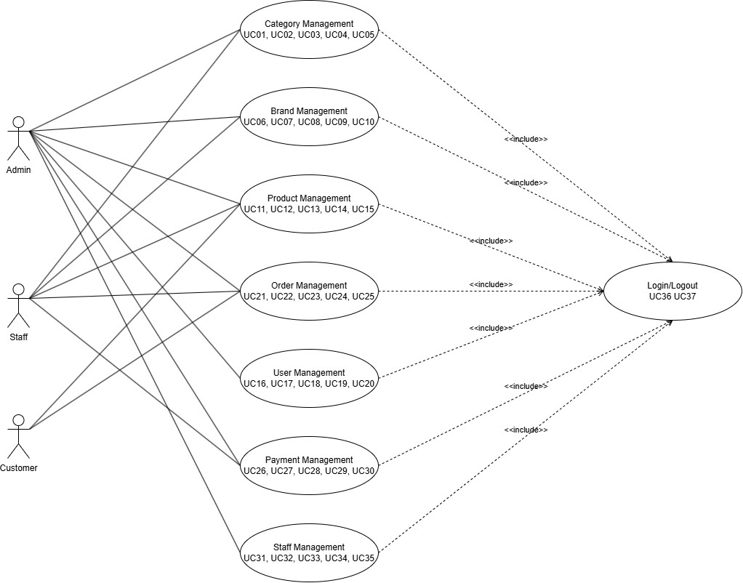

Figure 2.1 General Usecase

Figure 2.1 shows the overall use case diagram of the system, including the admin use cases and the accounts created by the admin to serve each specialized business. All use cases of those accounts have an include relationship with the Login and Logout use cases.

### ***2.2.2 Use Case Decomposition Diagram of Portfolio Management***

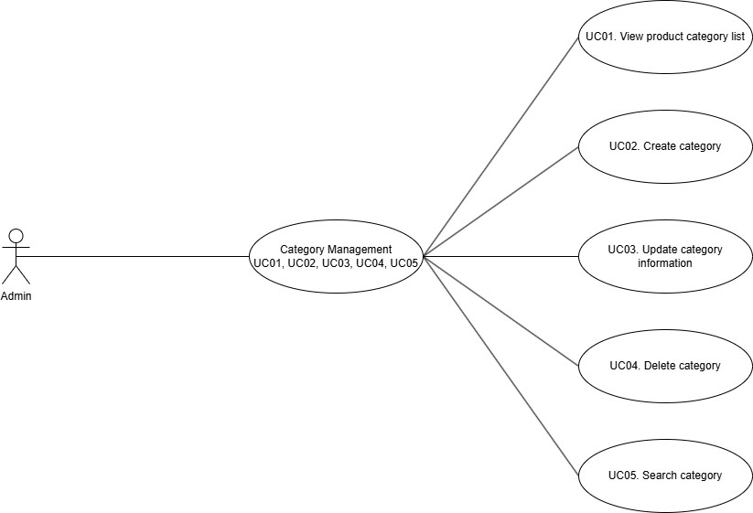

**Figure 2.2 Functional decomposition of the catalog management usecase**

Figure 2.2 shows the Product Portfolio Management use case decomposition diagram. A brief description of the use cases is shown in Table A.1 below.

### ***2.2.3 Use Case Decomposition Diagram of Portfolio Management***

## 2.3. Database Design

### **2.3.1. Entity-Relationship Diagram (ERD)**

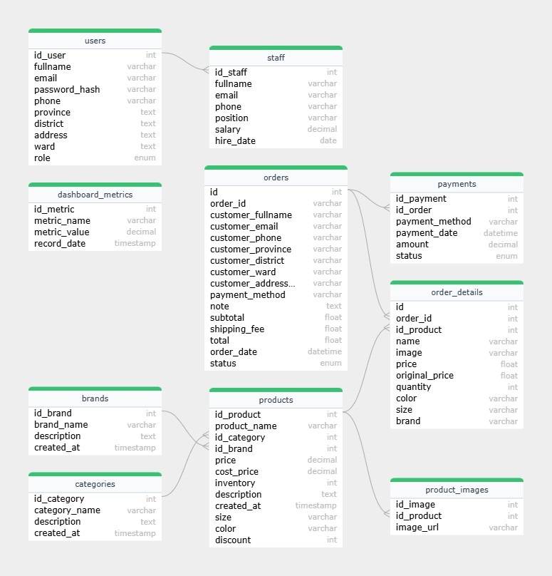

**Figure 2. Entity relationship diagram**

Figure 2.x Describing entities and relationships between entities

### **2.3.2. Table Descriptions and Relationships**

|  |  |  |
| --- | --- | --- |
| **Name column** | **Data Type** | **Description** |
| id_brand | INT | Primary key, auto-increment |
| brand_name | VARCHAR(255) | Brand name; cannot be null |
| description | TEXT | Description of the brand |
| created_at | TIMESTAMP | Record creation time |

Table 2.1 brands

|  |  |  |
| --- | --- | --- |
| **Name column** | **Data Type** | **Description** |
| id_category | INT | Primary key, auto-increment |
| category_name | VARCHAR(255) | Category name |
| description | TEXT | Description of the category |
| created_at | TIMESTAMP | Record creation time |

Table 2.2 categories

|  |  |  |
| --- | --- | --- |
| **Name column** | **Data Type** | **Description** |
| id_metric | INT | Primary key, auto-increment |
| metric_name | VARCHAR(255) | Name of the metric |
| metric_value | DECIMAL(10,2) | Value of the metric |
| record_date | TIMESTAMP | Date when the metric was recorded |

Table 2.3 dashboard_metrics

|  |  |  |
| --- | --- | --- |
| **Name column** | **Data Type** | **Description** |
| id | INT | Primary key, auto-increment |
| order_id | VARCHAR(20) | Unique order identifier; cannot be null |
| customer_fullname | VARCHAR(255) | Customer's full name |
| customer_email | VARCHAR(255) | Customer's email address |
| customer_phone | VARCHAR(20) | Customer's phone number |
| customer_province | VARCHAR(100) | Customer's province/state |
| customer_district | VARCHAR(100) | Customer's district |
| customer_ward | VARCHAR(100) | Customer's ward |
| customer_address_detail | VARCHAR(255) | Detailed customer address |
| payment_method | VARCHAR(255) | Detailed customer address |
| note | VARCHAR(50) | Payment method |
| subtotal | FLOAT | Order note |
| shipping_fee | FLOAT | Shipping fee |
| total | FLOAT | Total amount |
| order_date | DATETIME | Order date (defaults to current timestamp) |
| status | ENUM('pending','approved','refused') | Order status (pending, approved, or refused) |

Table 2.4 Order

|  |  |  |
| --- | --- | --- |
| **Name column** | **Data Type** | **Description** |
| id | INT | Primary key, auto-increment |
| order_id | INT | Foreign key referencing orders(id) |
| id_product | INT | Foreign key referencing products(id_product) (if applicable) |
| name | VARCHAR(255) | Name of the product ordered |
| image | VARCHAR(255) | Image URL of the ordered product |
| price | FLOAT | Price at the time of ordering |
| original_price | FLOAT | Original price of the product |
| quantity | INT | Quantity ordered |
| color | VARCHAR(50) | Product color |
| size | VARCHAR(50) | Product size |
| brand | VARCHAR(100) | Product brand |

Table 2.4 Order_detail

|  |  |  |
| --- | --- | --- |
| **Name column** | **Data Type** | **Description** |
| id_payment | INT | Primary key, auto-increment |
| metric_name | VARCHAR(255) | Foreign key referencing orders(id) |
| payment_method | VARCHAR(255) | Payment method |
| payment_date | DATETIME | Date of payment |
| Enum | DEMICAL(10,2) | Payment amount |
| status | ENUM('paid','unpaid','refunded') | Payment status (paid, unpaid, or refunded) |

Table 2.5 payment

|  |  |  |
| --- | --- | --- |
| **Name column** | **Data Type** | **Description** |
| id_product | INT | Primary key, auto-increment |
| product_name | VARCHAR(255) | Product name |
| id_categorry | INT | Foreign key referencing categories(id_category) |
| id_brand | INT | Foreign key referencing brands(id_brand) |
| price | DEMICAL(10,2) | Selling price |
| cost_price | DEMICAL(10,2) | Cost price |
| inventory | INT | Stock quantity |
| description | TEXT | Detailed description of the product |
| created_at | TIMESTAMP | Creation timestamp (defaults to CURRENT_TIMESTAMP) |
| size | VARCHAR(50) | Product size (if applicable) |
| color | VARCHAR(50) | Product color (if applicable) |
| discount | INT | Discount percentage (defaults to 0) |

Table 2.5 product

|  |  |  |
| --- | --- | --- |
| **Name column** | **Data Type** | **Description** |
| id_image | INT | Primary key, auto-increment |
| id_product | INT | Foreign key referencing products(id_product) |
| image_url | VARCHAR(255) | URL of the product image |

Table 2.6 product_images

|  |  |  |
| --- | --- | --- |
| **Name column** | **Data Type** | **Description** |
| id_user | INT | Primary key, auto-increment |
| fullname | VARCHAR(255) | User's full name |
| email | INT | User's email address; must be unique |
| password_hash | INT | Hashed password |
| phone | DEMICAL(10,2) | Phone number |
| province | DEMICAL(10,2) | Province/State |
| district | INT | District |
| address | TEXT | Detailed address |
| ward | TEXT | Ward/Commune |
| role | ENUM('customer','admin','staff') | Role of the user (customer, admin, or staff) |

Table 2.7 User

|  |  |  |
| --- | --- | --- |
| **Name column** | **Data Type** | **Description** |
| id_staff | INT | Primary key and foreign key referencing users(id_user); each staff member is a user |
| fullname | VARCHAR(255) | Staff memberr’s full name |
| email | VARCHAR(255) | User's email address; must be unique |
| password_hash | VARCHAR(255) | Staff email address; must be unique |
| phone | VARCHAR(15) | Phone number |
| province | VARCHAR(255) | Job position |
| salary | DECIMAL(10,2) | Salary amount |
| Hire-date | DATE | Hiring date |

Table 2.8 Staff

**2.4 Introduction to the Language and Its Usage**

### **2.4.1 Python**

Python is a high-level programming language commonly used for web and software development, task automation, and data analysis. As a general-purpose language, Python can be used to create a wide range of applications and is not limited to any specific problem domain.

With its beginner-friendly nature and flexibility, Python has become one of the most widely used programming languages today. As of 2023, Python was the most popular programming language among developers, holding a 14.82% market share, according to the TIOBE index.



**Figure 2.x: Python**

**Applications of Python**

**Data Analysis and Machine Learning**

In the field of data science, Python has become a crucial tool, enabling data analysts and other professionals to perform complex statistical calculations, create data visualizations, build machine learning algorithms, manipulate and analyze data, and complete other data-related tasks.

Python allows the creation of various types of data visualizations, including line and bar charts, pie charts, and 3D plots. Additionally, several Python libraries, such as TensorFlow and Keras, help developers build machine learning and data analysis programs more quickly and efficiently.

**Web Development**

Python offers several frameworks for web development, with Django and Flask being among the most widely used. Python’s role in web development includes sending and receiving data from servers, processing data, interacting with databases, routing URLs, and ensuring security. It is primarily used for back-end development, handling the parts of websites or applications that users do not directly see.

Job roles that utilize Python in web development include DevOps engineers, software engineers, Python developers, and back-end engineers.

**Software Development and Process Automation**

Scripting is a process used to automate workflows using Python. Automating tasks can improve efficiency significantly. In coding, automation can be used for error checking across multiple files, file conversions, performing simple calculations, and eliminating duplicate data.

Python also supports software development tasks such as build control, bug tracking, and testing. Software developers can use Python to automate tests for new products or features. Beginners can leverage Python to automate basic tasks on their computers—such as renaming files, searching and downloading online content, or sending emails and text messages at scheduled intervals. Python tools like Green and Requeistium are commonly used for software testing.

**Characteristics of Python**

* Python is processed at runtime by the Python interpreter.
* It supports object-oriented programming features and techniques.
* The Python interpreter allows direct interaction with users for writing programs.
* Python is easy to learn, especially for beginners or those from non-programming backgrounds.
* Its simple and readable syntax makes Python popular.
* Python is extensible, allowing users to add low-level modules to the interpreter.
* Python provides a well-structured environment to support large programs, following shell-script programming.

### **2.4.2 Flask**

Flask is a micro-framework written in Python, similar to Django, and is specifically designed for web developers. It is widely used for building websites, ranging from simple applications to more complex systems.

Flask is based on two key components: **Werkzeug WSGI** and **Jinja2 template engine**. Despite being called a micro-framework, Flask is not lacking in essential functionalities for web applications. It provides core features, is highly extensible, and allows users to customize it according to their needs. Additionally, Flask offers various extensions that enable the integration of intelligent features such as databases, file uploads, authentication, templating, and email services.



**Figure 2.x: Flask**

**Key Roles and Pros/Cons of Using Flask**

**Key Roles**

* Flask offers significant benefits for developers. First, it provides a flexible and easy-to-use framework, allowing developers to focus on the business logic of their application without being constrained by rigid rules.
* Flask integrates a powerful template engine, **Jinja2**, making it easy to create dynamic user interfaces. The support for **RESTful dispatching** is also a major advantage when developing interactive applications and APIs.
* Moreover, Flask has a large and active community that provides extensive documentation and resources. The growth and expansion of Flask through extensions and community libraries help developers save time and effort in building web applications.

**Advantages**

* **Flexibility:** Flask is designed to be adaptable and easily customizable to meet the specific needs of different projects.
* **Easy to Learn and Use:** It has a simple structure, well-documented resources, and an intuitive syntax, making it accessible to both beginners and experienced developers.
* **Versatile:** Flask allows integration with various technologies and additional libraries, from front-end tools to database management and networking services.
* **Efficient for Small to Medium Applications:** It is well-suited for developing small to medium-scale web applications with good performance.

**Disadvantages**

* **Scalability:** Flask does not come with built-in large-scale features like full-stack frameworks, which can increase complexity when integrating multiple advanced functionalities.
* **Not Ideal for Large Applications:** It is not the best choice for large-scale applications that require high performance and complex architectures.

**Core Features of Flask Framework**

Flask possesses several essential features that developers commonly use to build efficient web applications. Some of its key features include:

* **Lightweight and Easy to Use:** Flask has a minimalistic structure with readable code, allowing developers to quickly understand and customize it for their specific needs.
* **Flexible Routing:** It provides a routing mechanism that enables developers to define URL patterns and map them to corresponding handler functions, ensuring efficient HTTP request management.
* **Template Engine:** Flask integrates **Jinja2**, a powerful templating engine that helps in creating dynamic web interfaces.
* **Highly Extensible:** Despite being a micro-framework, Flask supports strong extensibility through various community-developed extensions. Users can add features like authentication, navigation, database interactions, and more.
* **Built-in Development Server:** Flask comes with an integrated development server, allowing developers to test and develop applications without additional configurations.
* **RESTful Request Handling:** It supports building RESTful APIs and web services efficiently.
* **Large and Active Community:** Flask has a vast user base with strong support from the Python community, making it easier for developers to find resources, documentation, and troubleshooting assistance.

### 2.4.3 SQLite



**Figure 2.x: SQLite**

**What is SQLite?**

SQLite is a relational database management system (DBMS) similar to MySQL. One of its standout features compared to other DBMSs is its compact, lightweight, and simple design. In particular, it does not require a client-server model—there is no need for installation, configuration, or startup processes—so there is no concept of user accounts, passwords, or privileges in an SQLite database. All data is stored in a single file.

SQLite is typically not used in large-scale systems; however, for small to medium-sized systems, SQLite is comparable to other DBMSs in both functionality and speed. Since it does not require installation or configuration, SQLite is widely used for development and testing, avoiding the complications associated with setup.

**Features of SQLite**

* **ACID Transactions:**  
  Transactions in SQLite adhere to ACID principles, ensuring data integrity even after system crashes or power failures.
* **No Configuration Needed:**  
  There is no need for setup or administration.
* **Advanced Capabilities:**  
  SQLite supports advanced features such as partial indexes, expression indexes, JSON support, and common table expressions.
* **Single-File Storage:**  
  A complete database is stored in one cross-platform file, making it ideal for use as an application file format.
* **Scalability:**  
  It supports databases up to terabytes in size and strings up to gigabytes in length.
* **Simple and Fast API:**  
  SQLite’s API is simple and easy to use, and in some cases, it can be faster than direct file system I/O.
* **ANSI-C Implementation:**  
  SQLite is written in ANSI-C, and bindings for dozens of other programming languages are available.
* **Open Source:**  
  Its full source code is open source and fully auditable.
* **Cross-Platform Compatibility:**  
  SQLite is available on Android, *BSD, iOS, Linux, Mac, Solaris, Windows, and can be easily ported to other systems.

**Primary Applications of SQLite**

* **Internet of Things (IoT):**  
  SQLite is commonly used as the database for IoT devices.
* **Mobile and Embedded Devices:**  
  It is a popular choice for database solutions in mobile phones, PDAs, MP3 players, set-top boxes, and other electronic devices.
* **Application File Format:**  
  Instead of using functions like fopen() to write data in XML, JSON, CSV, or other file formats, SQLite can be used to manage data in a more structured manner.
* **Web Databases:**  
  Because SQLite requires no configuration and stores data in ordinary disk files, it is a popular database solution for small to medium-sized websites.
* **Enterprise RDBMS Stand-In:**  
  SQLite is often used as an enterprise RDBMS for demonstration or testing purposes due to its speed and lack of setup requirements.

**Some Interesting Points About SQLite**

1. **AUTOINCREMENT:**
   * A column declared as INTEGER PRIMARY KEY will automatically increment.
   * When NULL is inserted into this column, it is automatically replaced with the next largest integer value.
2. **Data Types:**
   * SQLite uses a dynamic typing system. The data type is associated with the value itself rather than the container.
   * The supported data types include Integer, Real, Text, Blob, and Null.
   * SQLite does not strictly enforce data type constraints:
     + Any type of data can be inserted into any column; however, an INTEGER PRIMARY KEY can only accept a 64-bit integer.
     + The declared data type of a column is used as a hint for data formatting.
3. **Dropping a Column in a Table:**
   * SQLite supports the ALTER TABLE command, but it is limited to adding columns and renaming them.
   * To drop a column, the following steps are typically followed:
     + Create a new table containing only the necessary columns.
     + Copy data from the old table to the new table.
     + Drop the old table.
     + Recreate the table using the original table name.
     + Copy the data from the temporary table back into the new table.

### **2.4.4 Visual Studio Code**



Visual Studio Code is a powerful, lightweight, and cross-platform source code editor developed by Microsoft that has quickly become one of the most popular tools among developers worldwide. Designed with a focus on speed and simplicity, VS Code offers an intuitive user interface that caters to both beginners and seasoned professionals. It comes with built-in support for a wide range of programming languages and features, such as syntax highlighting, intelligent code completion (IntelliSense), and debugging tools, which significantly enhance the coding experience.

One of the standout features of Visual Studio Code is its extensive extension ecosystem. Developers can easily customize their environment by installing extensions that add language support, themes, debuggers, and other tools that streamline development workflows. This flexibility allows users to tailor the editor to meet the specific demands of their projects, whether they are working on web development, data science, or application programming. Additionally, the integrated Git support in VS Code makes version control a seamless part of the development process, enabling users to manage code changes, commit updates, and collaborate with teams directly from the editor.

Furthermore, Visual Studio Code’s active community contributes to its continuous improvement by providing regular updates, new extensions, and valuable feedback that drive innovation. Its cross-platform compatibility means that whether you're using Windows, macOS, or Linux, you can enjoy the same robust development environment. This universality, combined with its user-friendly features and performance efficiency, makes Visual Studio Code an indispensable tool in modern software development.

**CHAPTER 3: SOLUTION AND IMPLEMENTATION**

In this chapter, the focus shifts from planning and analysis to the practical realization of our proposed system. The solutions developed and implemented are designed to address the identified requirements and challenges effectively. I begin with a detailed look at the client user interface, which plays a crucial role in ensuring a seamless and engaging experience for the end users.

**3.1. Client User Interface**

### **3.1.1. Home Page**

The home page is the page where people will see an overview of all the functions of the website and at the same time, the home page also displays products that suit the needs of customers. Figures 4.1, 4.2, 4.3, 4.4, 4.5, 4.6 are the home page interface that customers see.

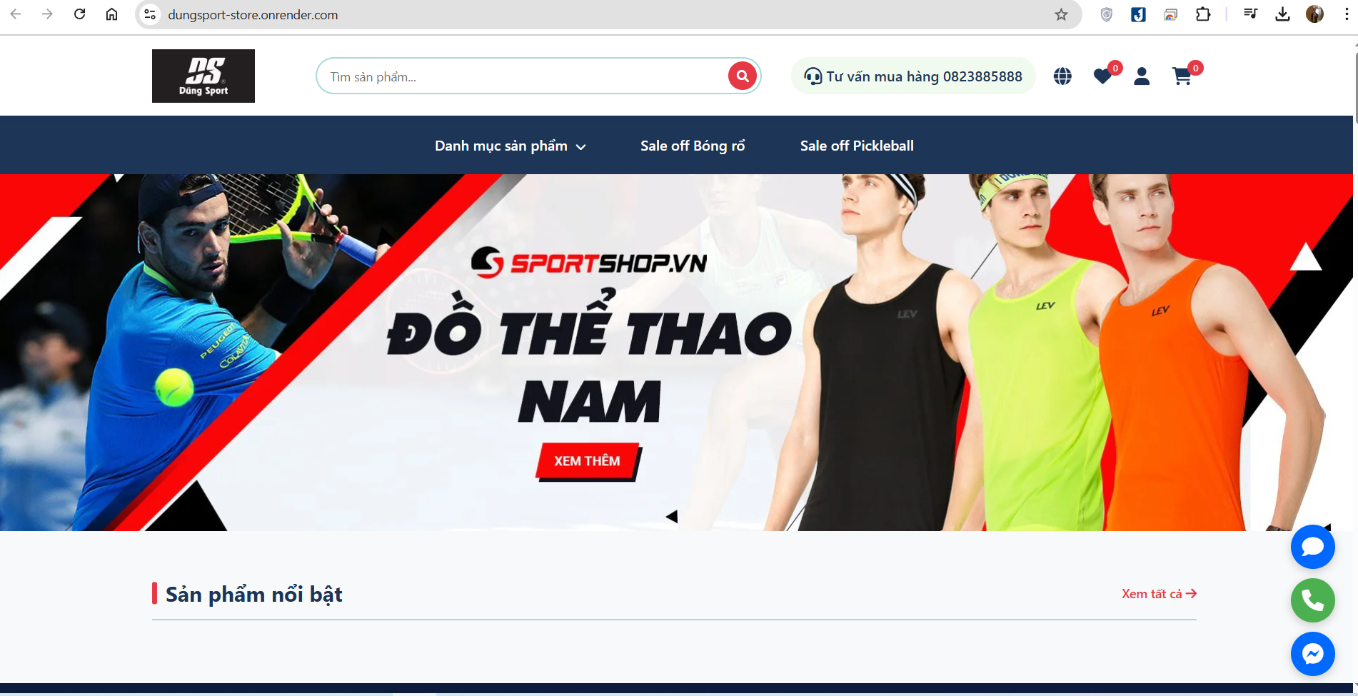

**Figure 4.1 Home Page Hero Banner**

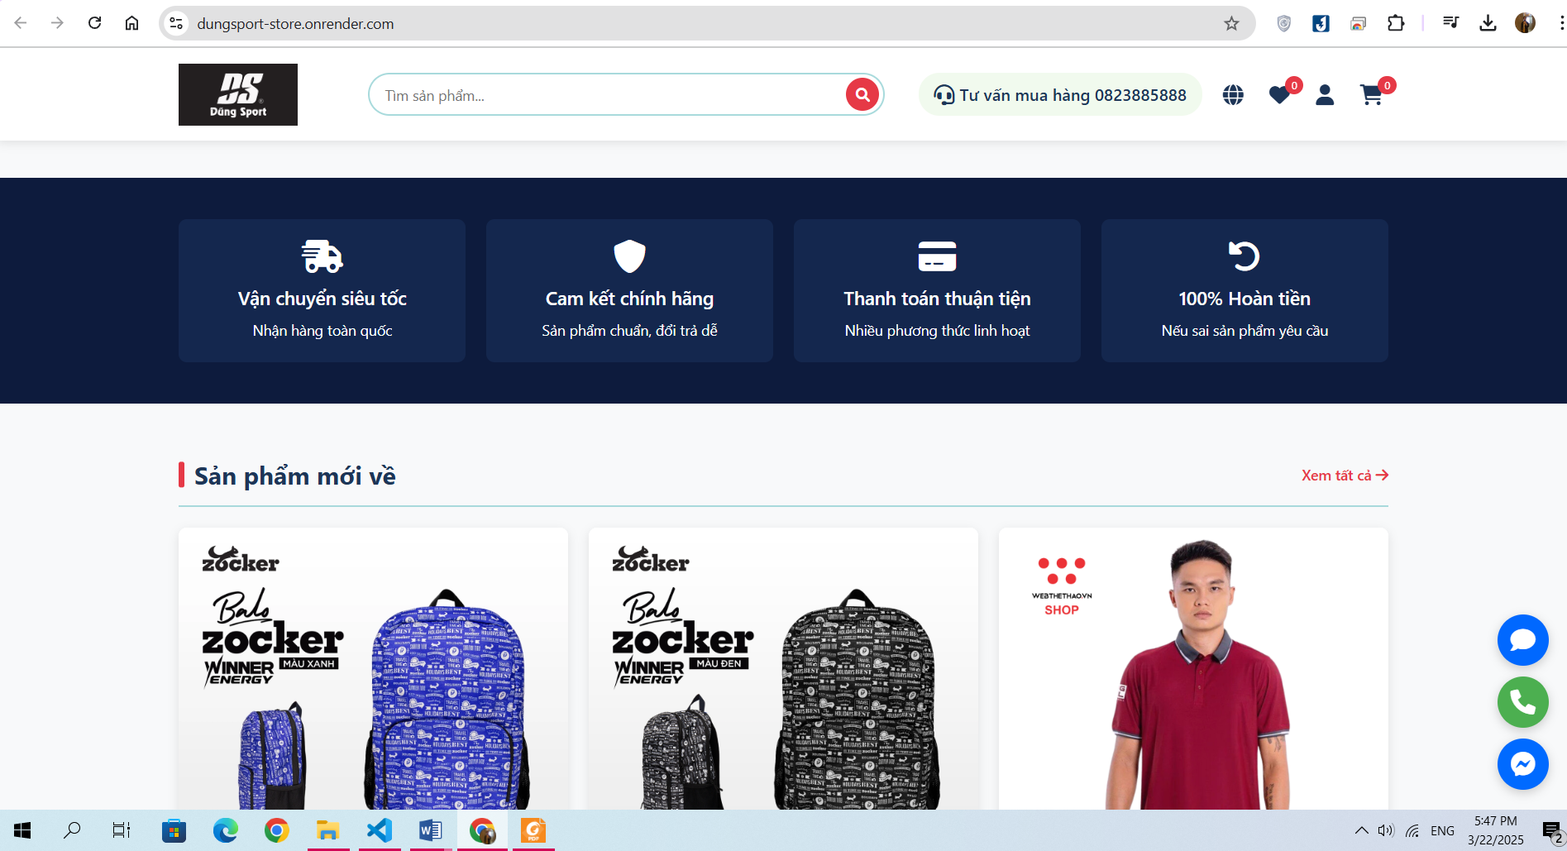

**Figure 4.2 Home Page New Arrival Section**

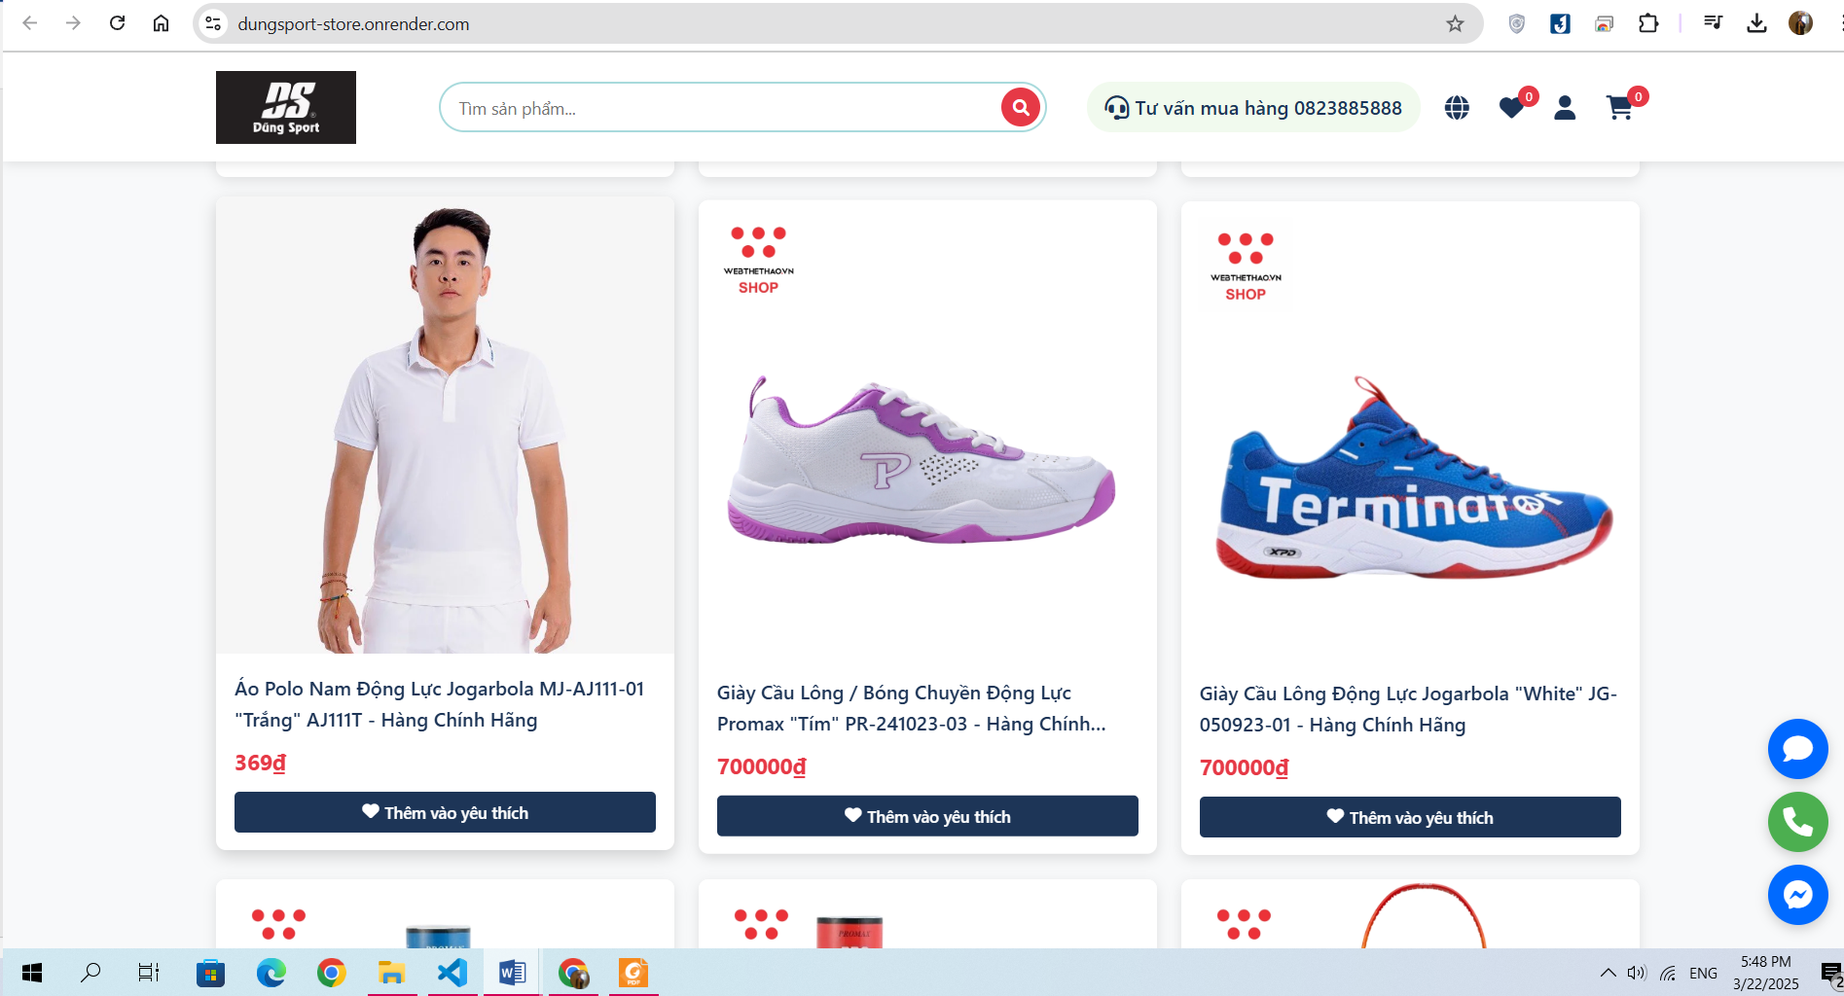

**Figure 4.3 Product list**

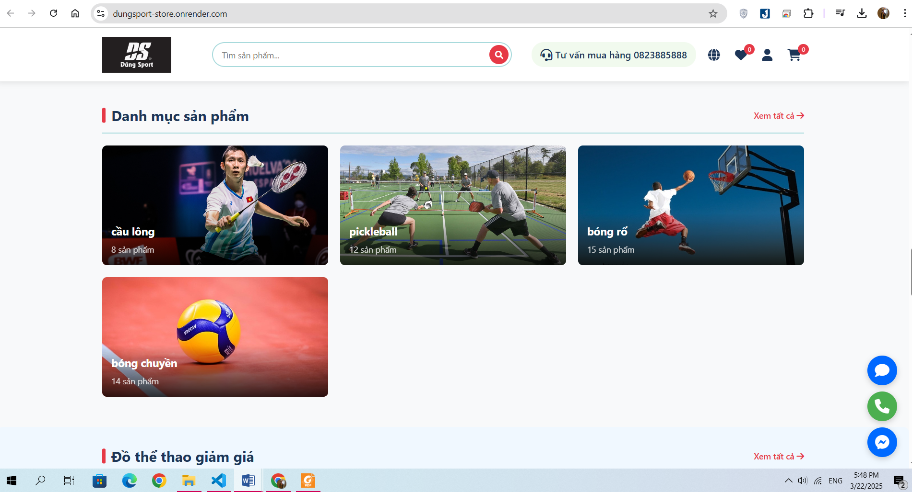

**Figure 4.4 Home page Category Section**

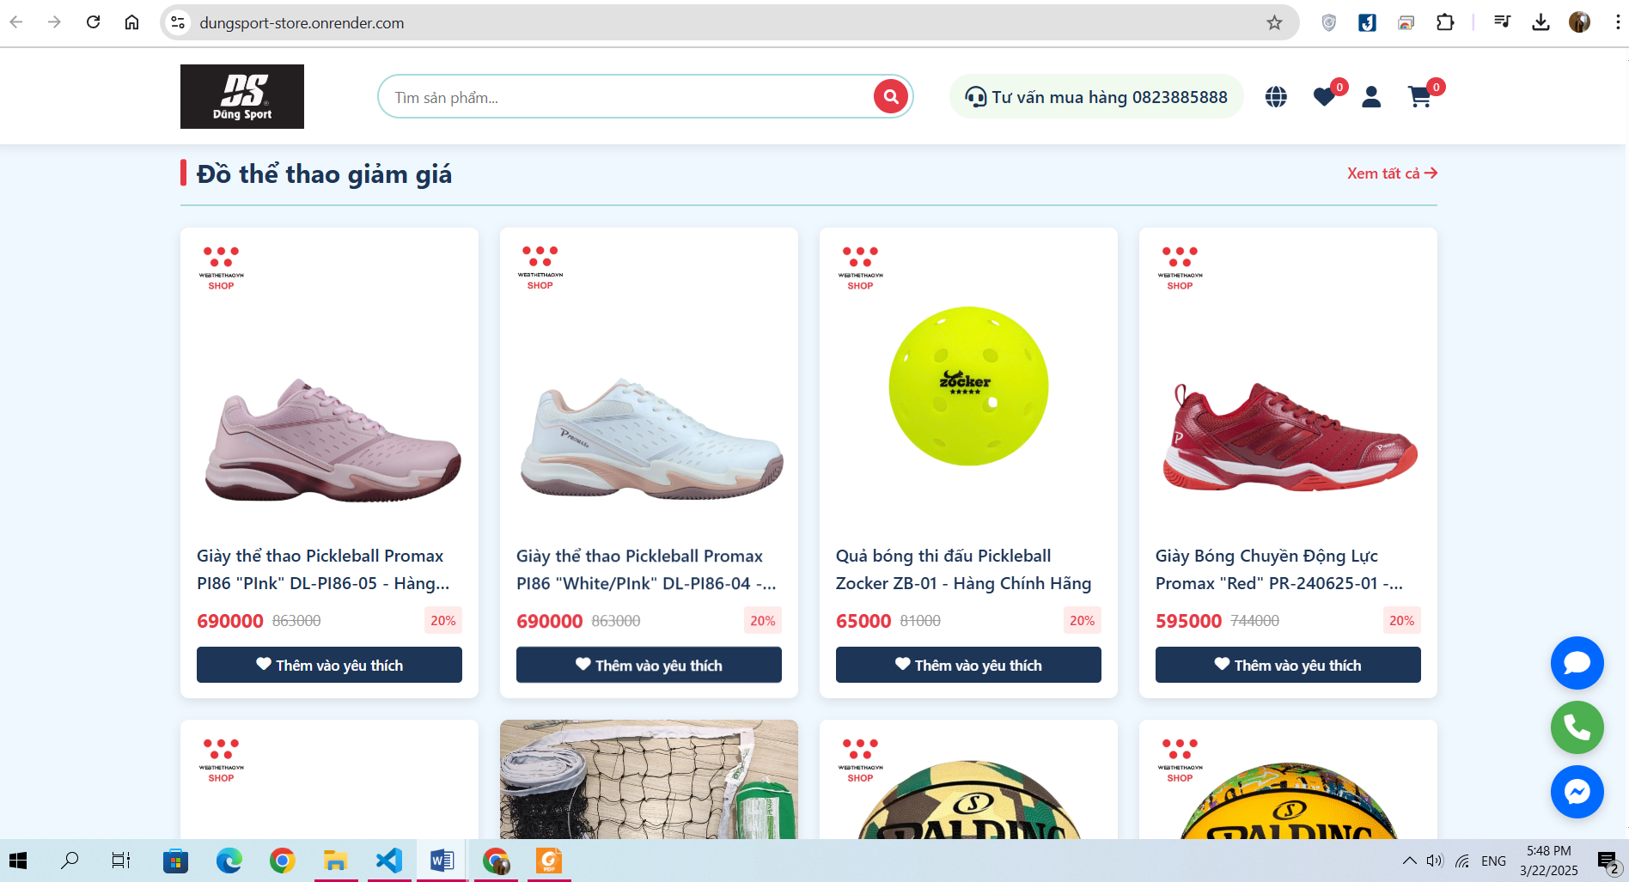

**Figure 4.5 Home page Sale off Product Section**

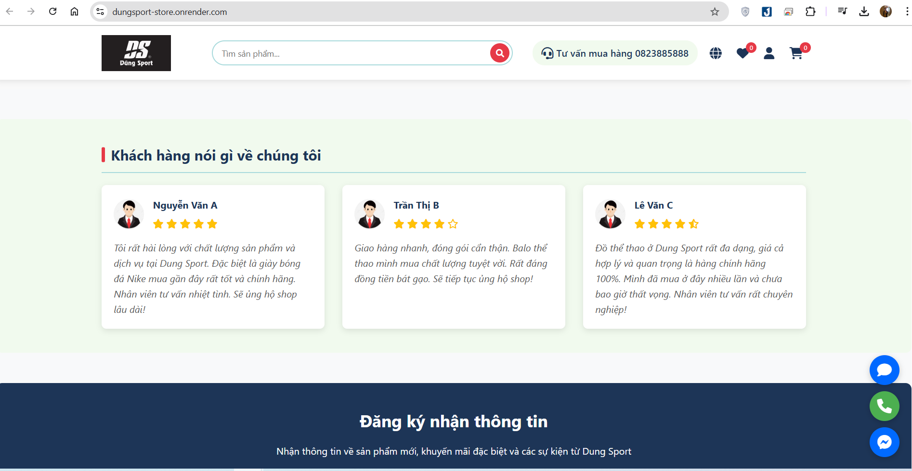

**Figure 4.6 Home page FeedBack Section**

### **3.1.2 Store System Page**

The Store System Page provides a visual representation of store locations on an interactive map. This page helps users quickly find the nearest store and navigate to their desired location.

Key Features:

* Interactive Map: Displays all store locations with precise markers.
* Store Information: Clicking on a store marker reveals details such as store name, address, and operating hours.
* Navigation Support: Integrates with mapping services to provide directions from the user’s current location.
* Responsive Design: Ensures compatibility across different devices, allowing users to access store locations easily.

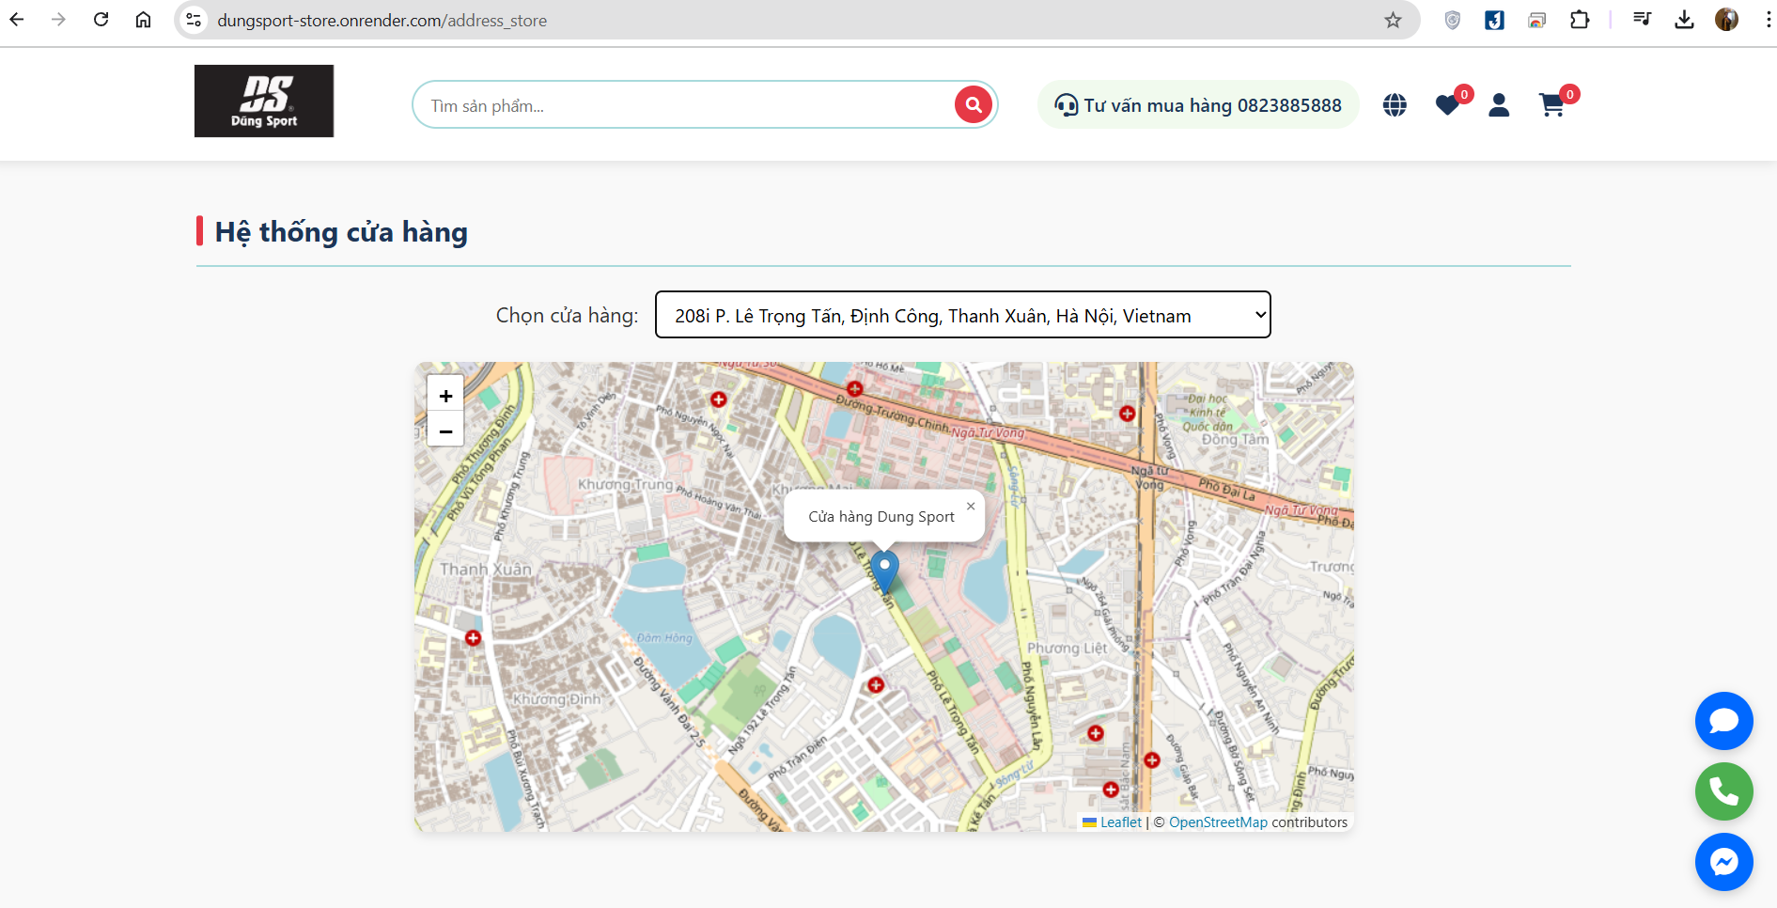

**Figure 4.7 Store System Page**

### **3.1.3 Favorite Product Page**

The Favorite Product Page allows users to save and manage their favorite products for quick access in future visits. This feature enhances the shopping experience by enabling users to keep track of items they are interested in without needing to search for them again.

**Key Features:**

* **Saved Favorites:** Displays a list of products that users have marked as favorites.
* **Quick Access:** Users can easily view and navigate to product details or add items to the cart directly.
* **Dynamic Updates:** Any changes in product availability, price, or promotions are reflected in real time.
* **User-Friendly Interface:** Clean and organized layout for seamless browsing and product management.

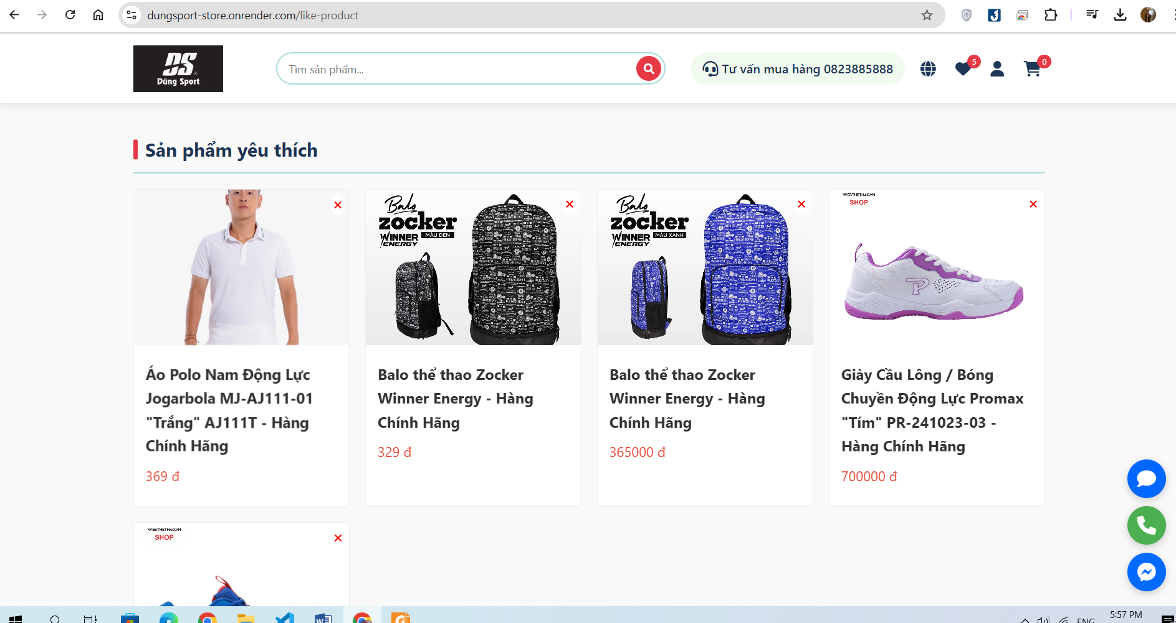

**Figure 4.8 Favorite Product Page**

### **3.1.4. Shopping Cart Page**

The Shopping Cart Page allows users to review and manage the products they have selected before proceeding to checkout. This page provides a clear and organized view of the items in the cart, ensuring a smooth shopping experience.

Key Features:

**Product Overview**: Displays a list of selected items, including product name, image, price, quantity, and total cost per item.

**Quantity Adjustment**: Users can increase or decrease the quantity of each product directly within the cart. The total price updates automatically based on changes.

**Remove Items:** Users can remove individual products from the cart with a single click.

**Cart Summary:** Shows the subtotal, applicable discounts, taxes, and final total amount to be paid.

**Proceed to Checkout Button:** Redirects users to the checkout page to complete their purchase.

**Continue Shopping Option:** Allows users to return to the product catalog and add more items.

The Shopping Cart Page ensures a user-friendly and efficient way to manage purchases, enhancing the overall e-commerce experience.

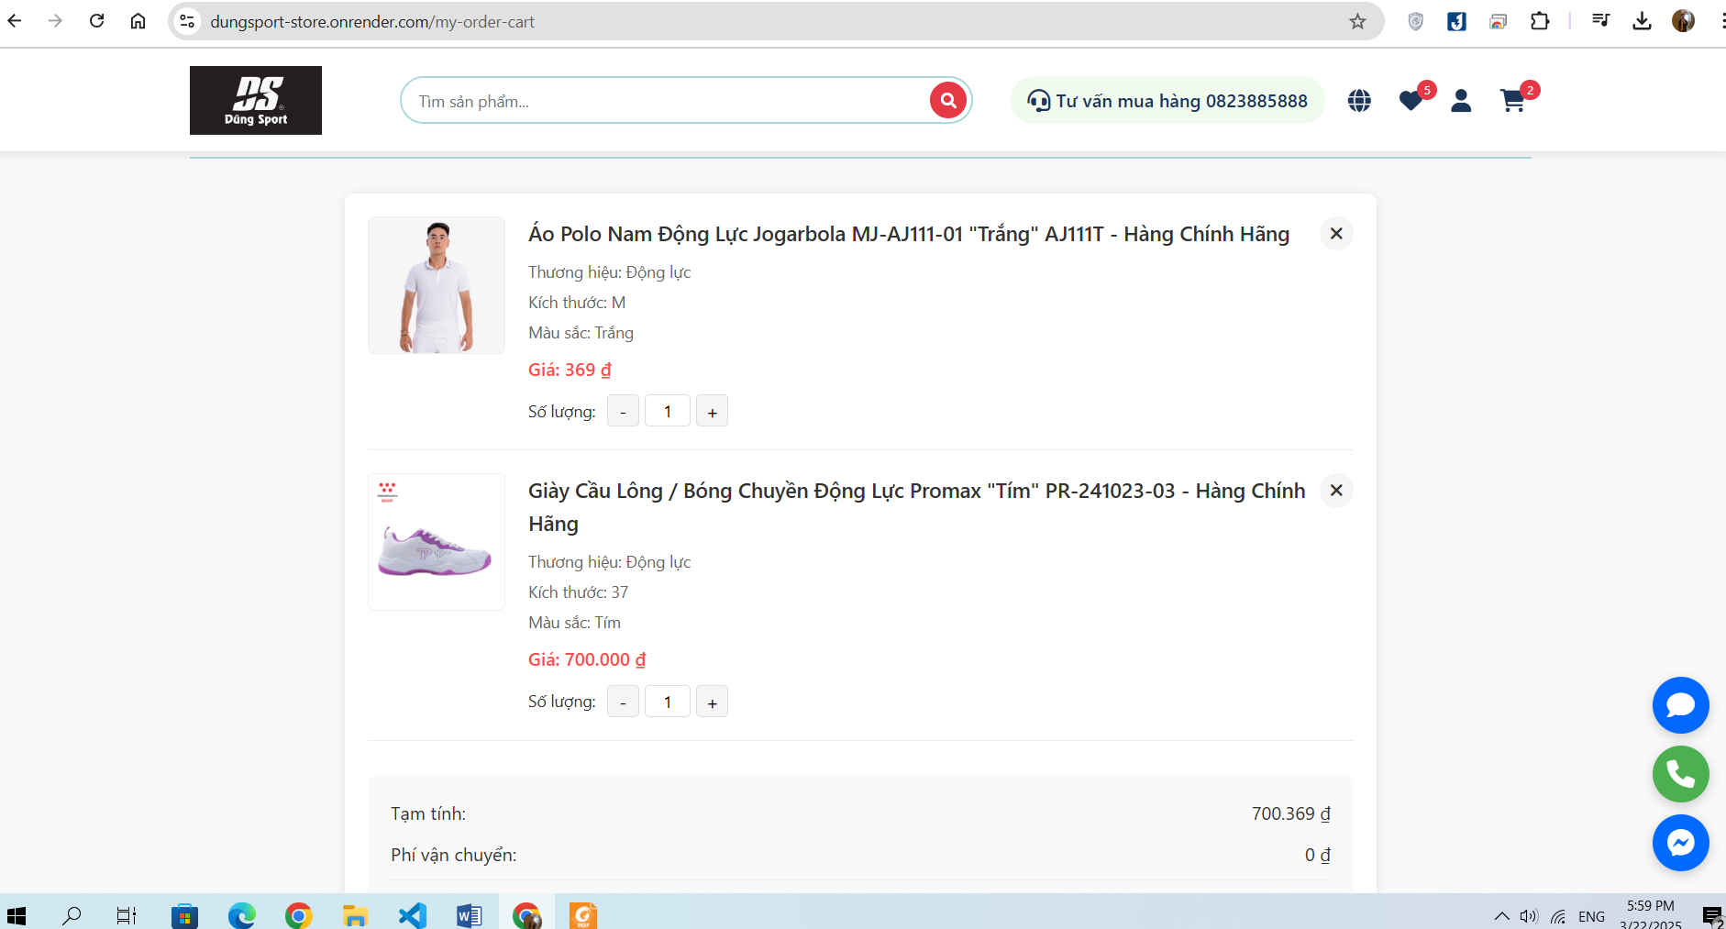

**Figure 4.9 Shopping Cart Page**

**3.1.5 Checkout Payment Page**

The Checkout & Payment Page is the final step in the purchasing process, allowing users to review their order, provide shipping details, and complete their payment securely. This page ensures a smooth and efficient transaction experience.

**Key Features:**

* **Order Summary:** Displays a detailed breakdown of selected items, including product names, quantities, prices, discounts, and total cost.
* **Shipping Information:** Users enter or select their saved shipping address for order delivery.
* **Payment Methods:** Supports multiple payment options such as credit/debit cards, digital wallets, bank transfers, and cash on delivery (if available).
* **Secure Transaction:** Ensures encrypted and secure payment processing to protect user data.
* **Promotional Codes & Discounts:** Allows users to apply coupon codes or loyalty points for additional savings.
* **Review & Confirmation:** Before completing the purchase, users can double-check all details and make necessary changes.
* **Order Success Notification:** Once the payment is processed, users receive a confirmation message along with an order tracking option.

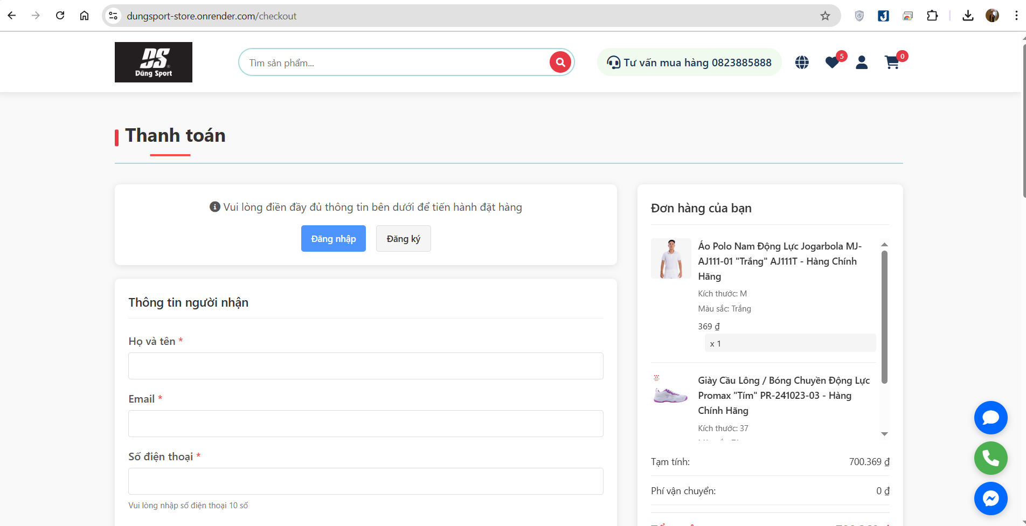

**Figure 4.10 Checkout Payment Page**

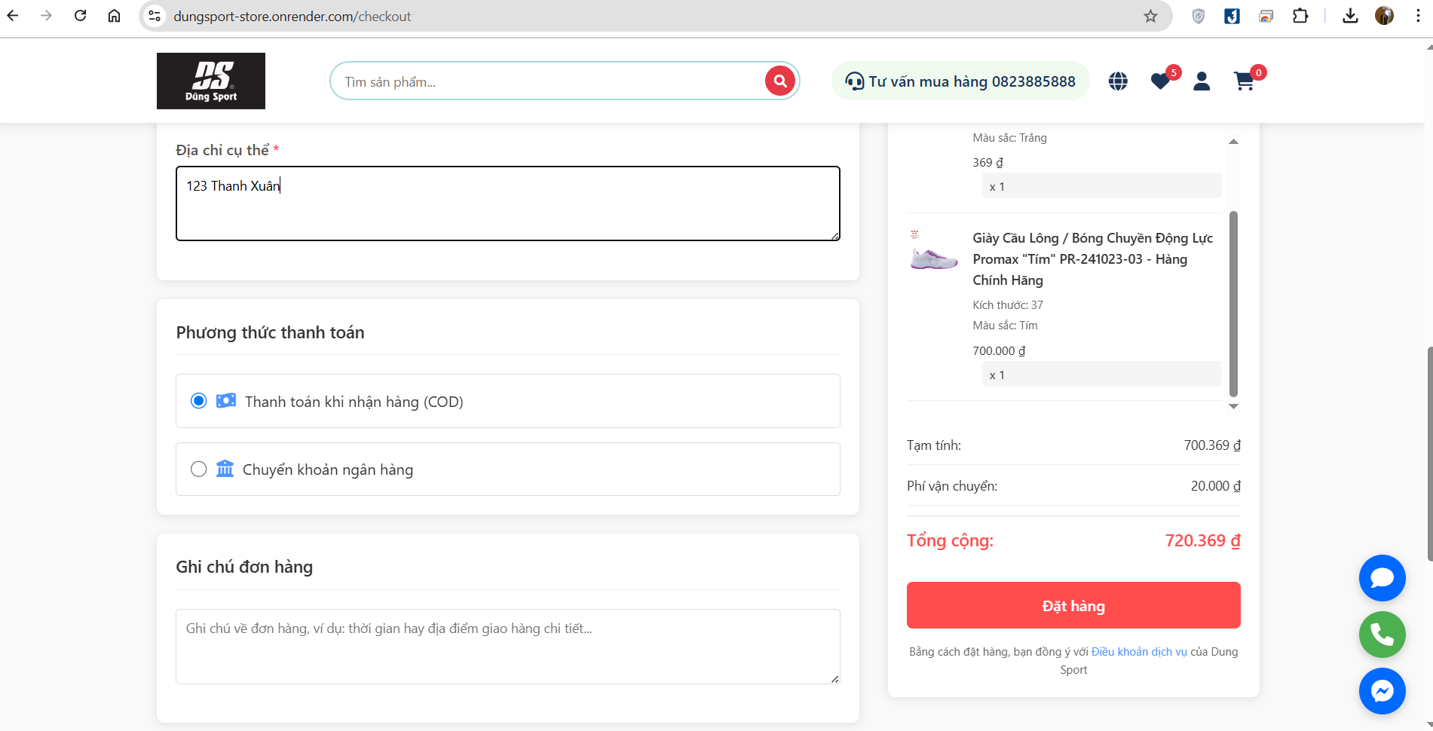

**Figure 4.11 Checkout Payment Page**

### **3.1.6 Login/Register Page**

The Login & Register Page serves as the entry point for users to access their accounts or create a new one. It ensures secure authentication and a seamless onboarding experience for both new and returning customers.

**Key Features:**

*Login Section:*

* Users can enter their registered email/phone number and password to access their account.
* Secure authentication to prevent unauthorized access.

*Register Section:*

* New users can create an account by providing essential details such as name, email/phone number, and password.
* Option to set up additional information like address and profile details.
* Terms and conditions agreement checkbox before account creation.

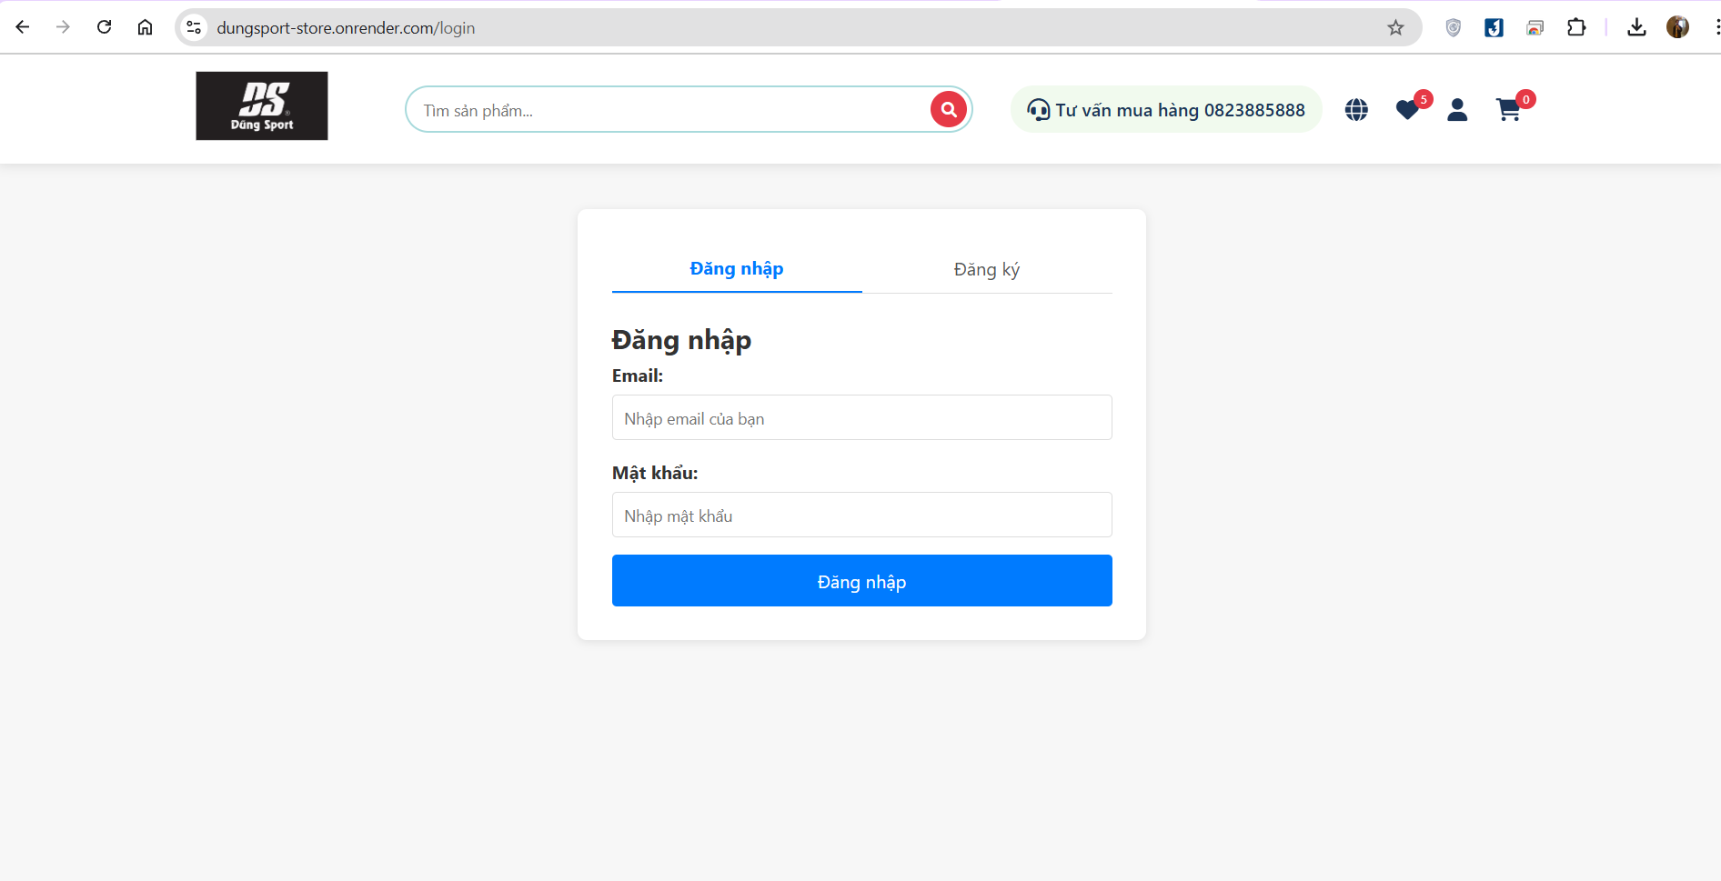

**Figure 4.12 Login Page**

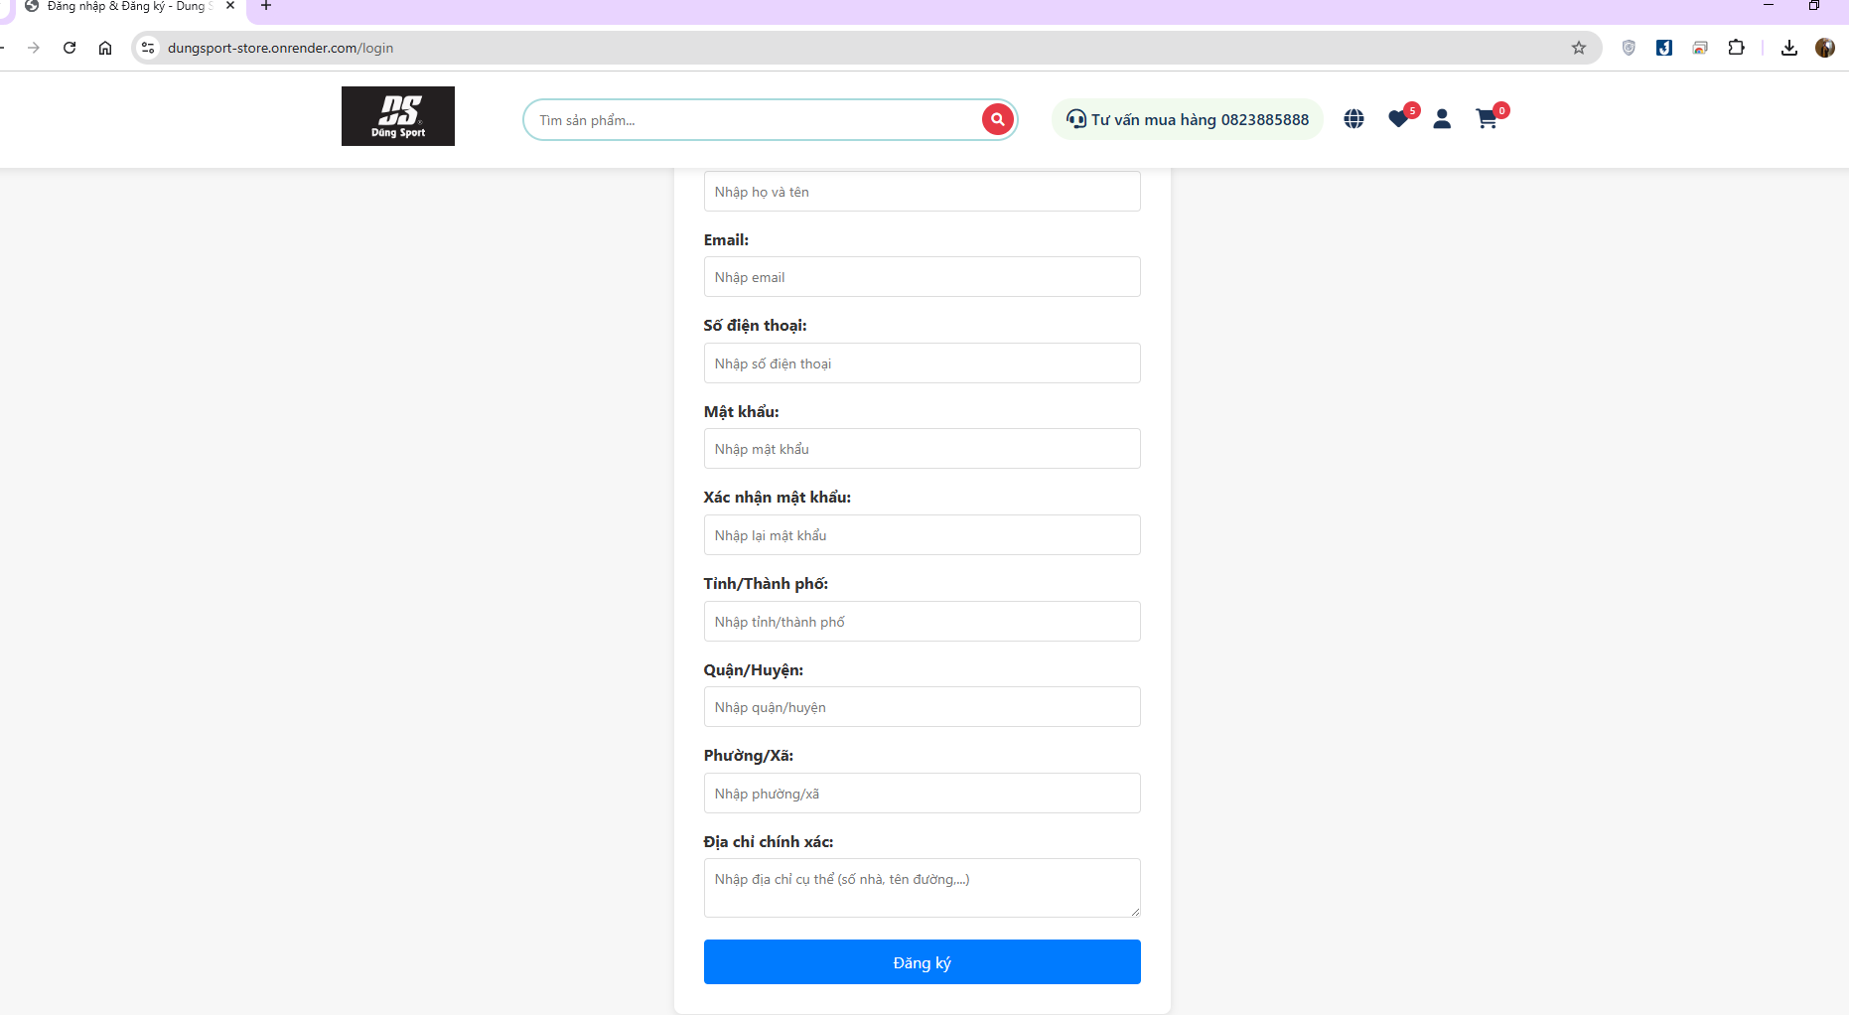

**Figure 4.13 Register Page**

### **3.1.7 User Information Page**

The User Information Page provides users with a centralized hub to manage their personal details, account settings, and preferences. It ensures a seamless experience for updating and maintaining user data.

***Key Features:***

* **Personal Information:** Displays essential details such as full name, email, phone number, and profile picture. Users can update their information as needed.
* **Address Management:** Allows users to add, edit, or delete shipping and billing addresses for convenience during checkout.

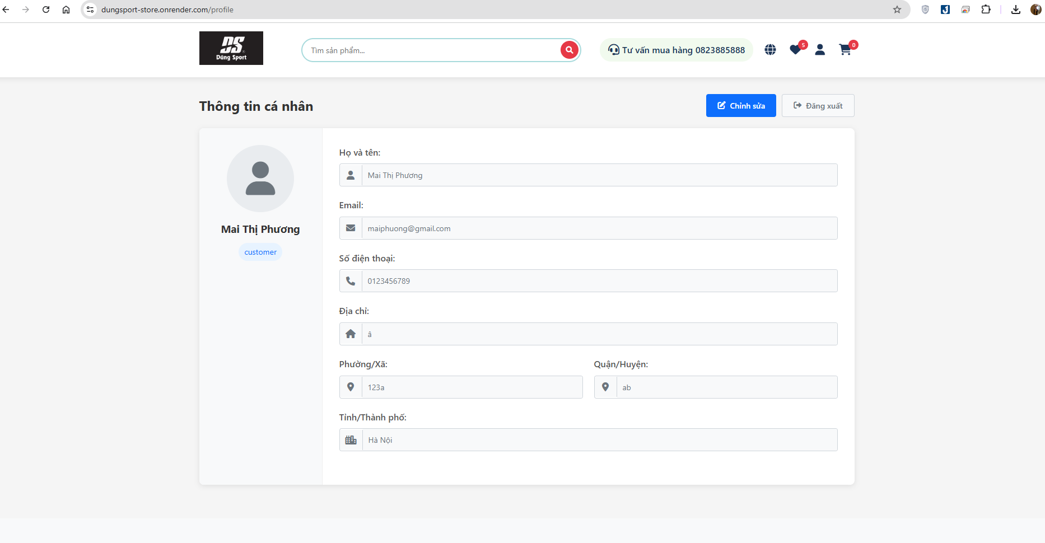

**Figure 4.14 User Information Page**

### **3.1.8 Search Product**

Search product information by name

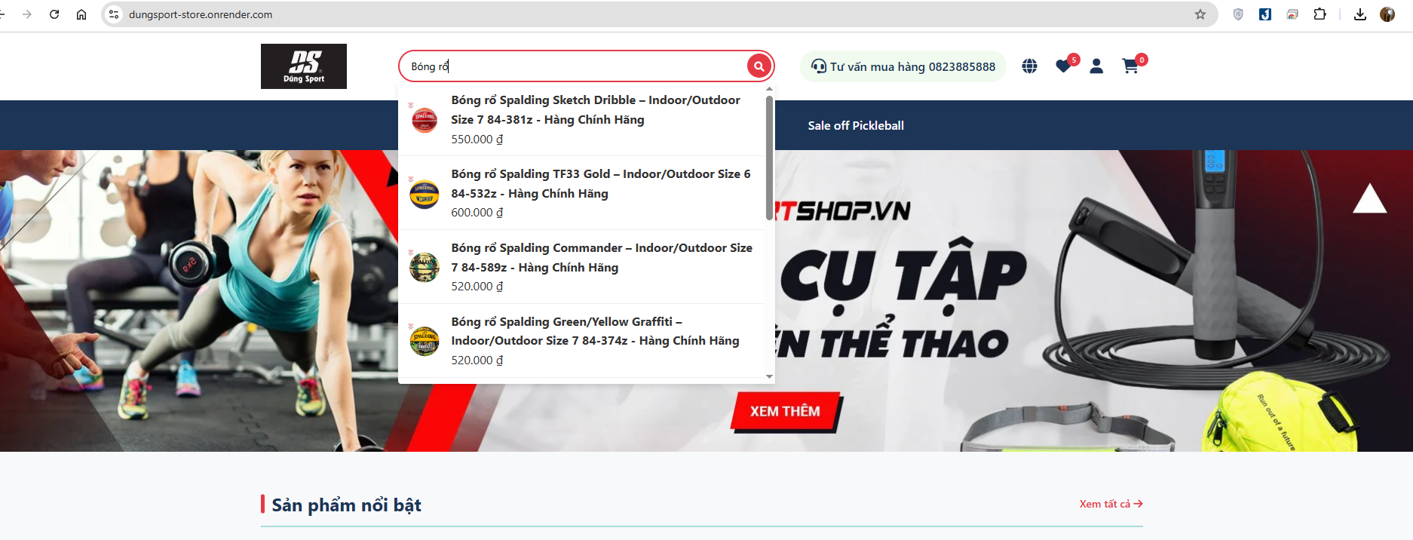

**Figure 4.15 Search Product**

**3.2. Admin User Interface**

### ***3.2.1. Admin Login Page***

The **Admin Login Page** is the gateway for administrators to access the management system. To use admin features and manage the platform, administrators must log in with valid credentials. This authentication ensures security and restricts access to authorized users only.

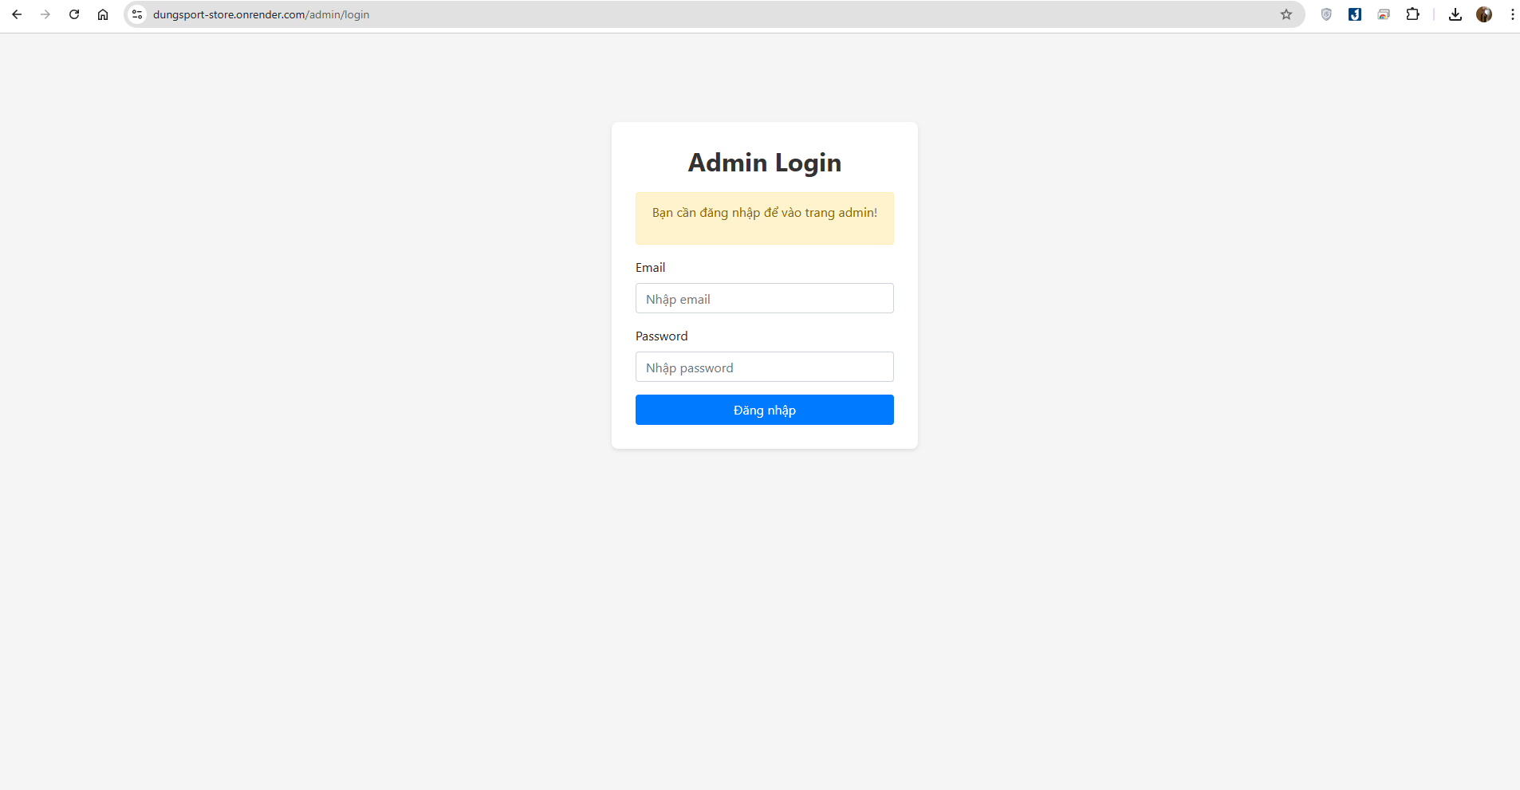

Figure 4.16 Admin Login Page

### **3.3.2. Dashboard Page**

The Dashboard Page serves as the central hub for administrators, providing an overview of key system metrics and functionalities. It displays essential data such as user activity, sales reports, product statistics, and system notifications. From this page, administrators can quickly navigate to different management sections, monitor performance, and make informed decisions efficiently.

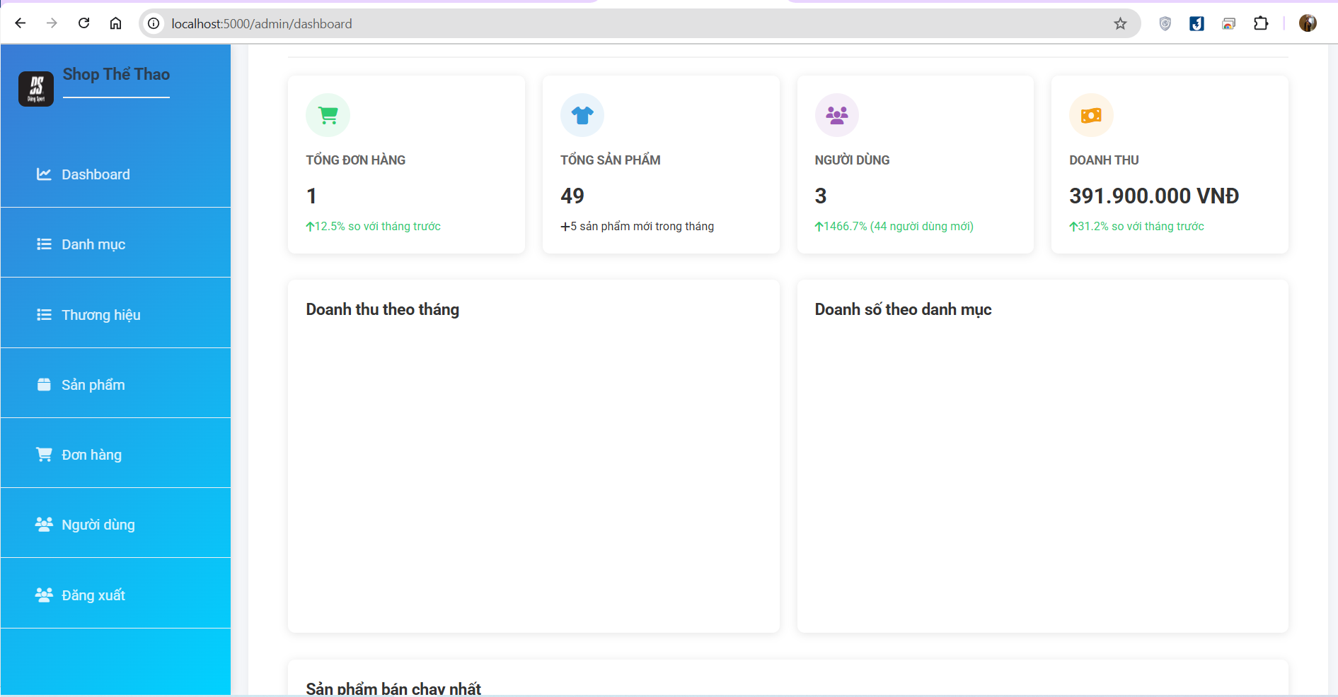

Figure 4. 17 Dashboard Page

### **3.3.3. Category Management Page**

The **Category Management Page** allows administrators to manage product categories efficiently. It provides functionalities to add, edit, and delete categories, ensuring a well-organized product structure. Each category can have a name, description, and possibly an image or icon for better identification. This page helps maintain a structured and user-friendly product catalog for easier navigation and management.

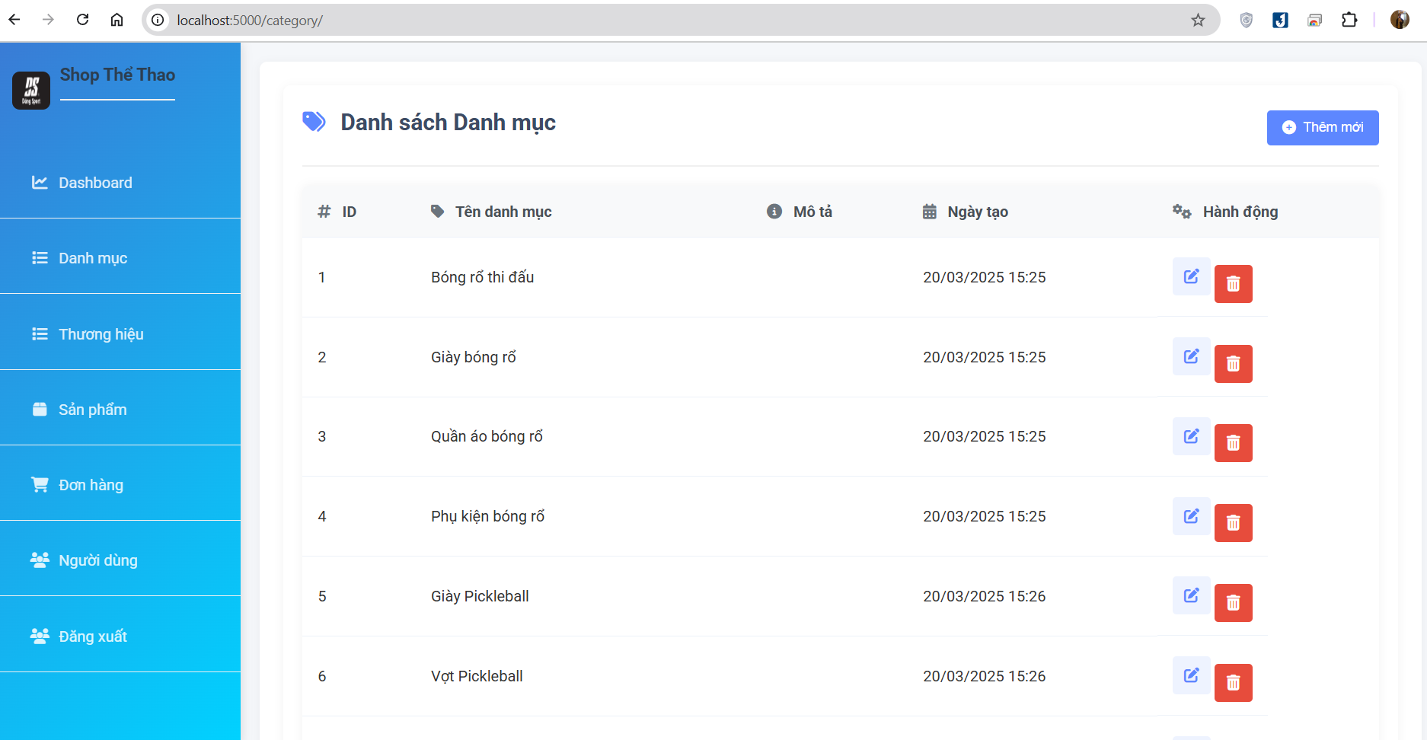

Figure 4. 18 View category list

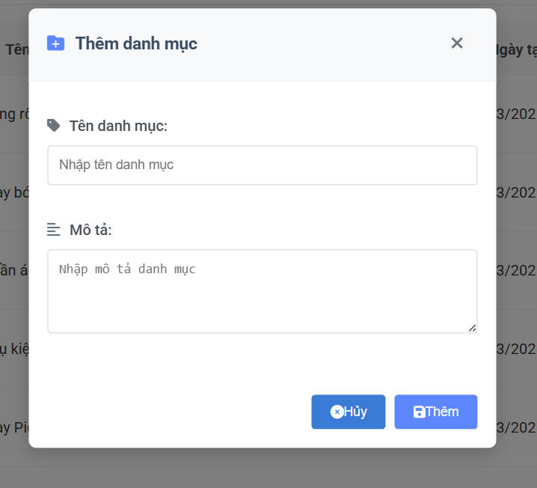

Figure 4. 19 Create new category

### **3.3.4 Brand Management Page**

The Brand Management Page enables administrators to manage product brands effectively. It provides functionalities to add new brands, edit existing ones, and delete unused brands. Each brand entry may include a name, logo, and description for better organization. This page ensures a well-structured brand catalog, making it easier to categorize and manage products in the system.

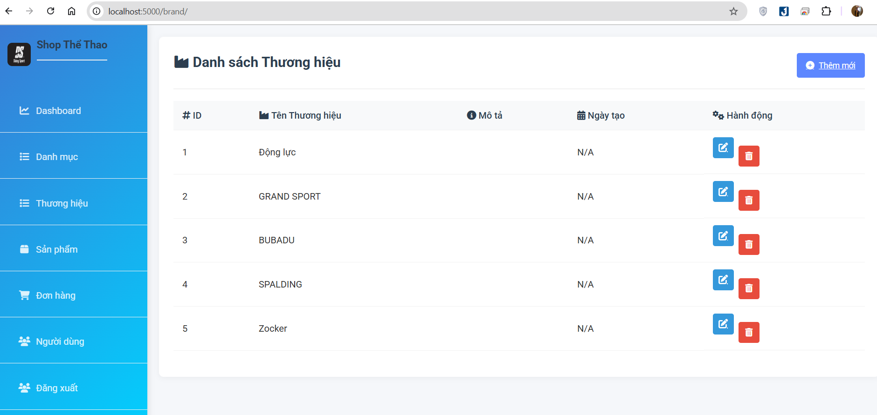

Figure 4. 20 View list brand

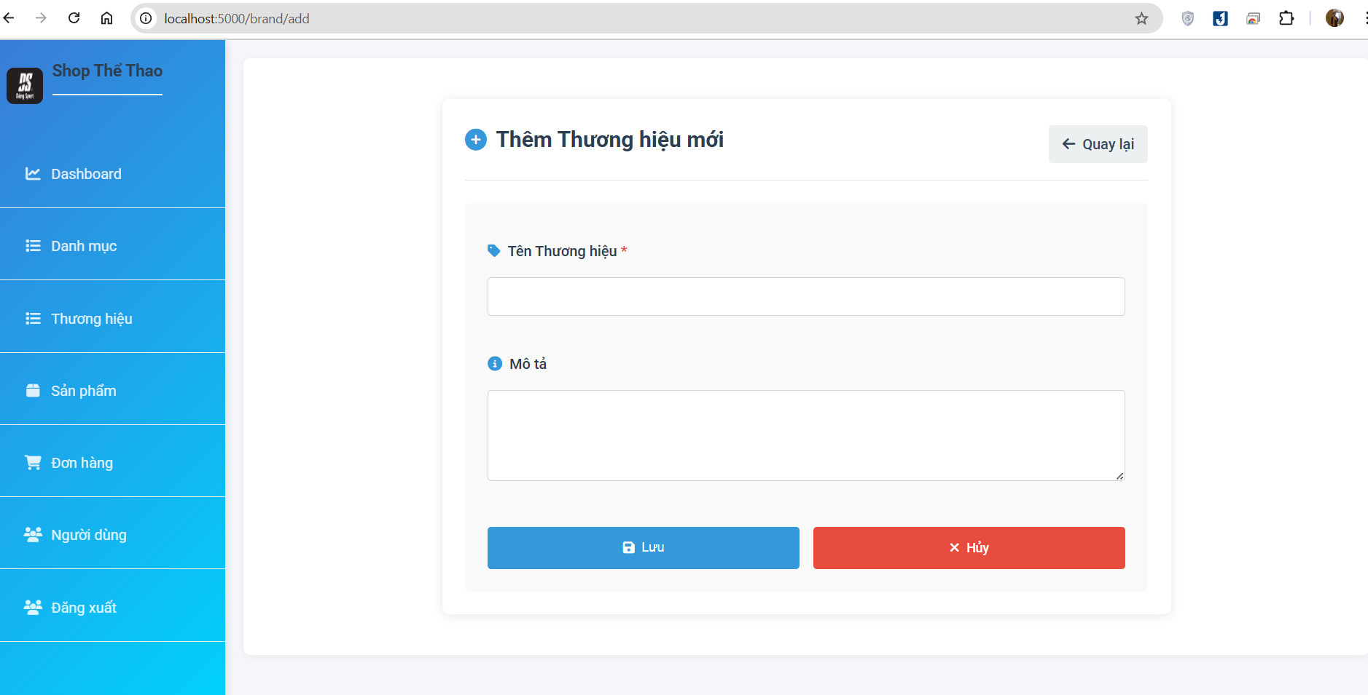

Figure 4. 21 Create new brand

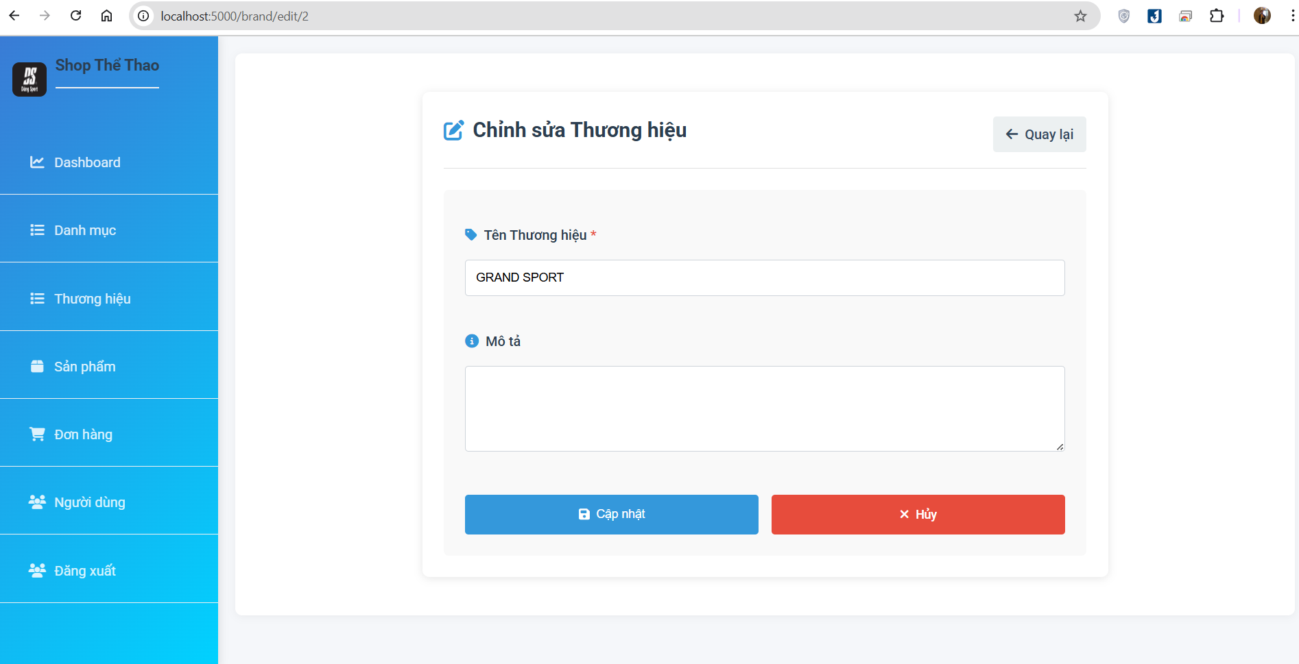

Figure 4. 22 Update information brand

### **3.3.5 Product Management Page**

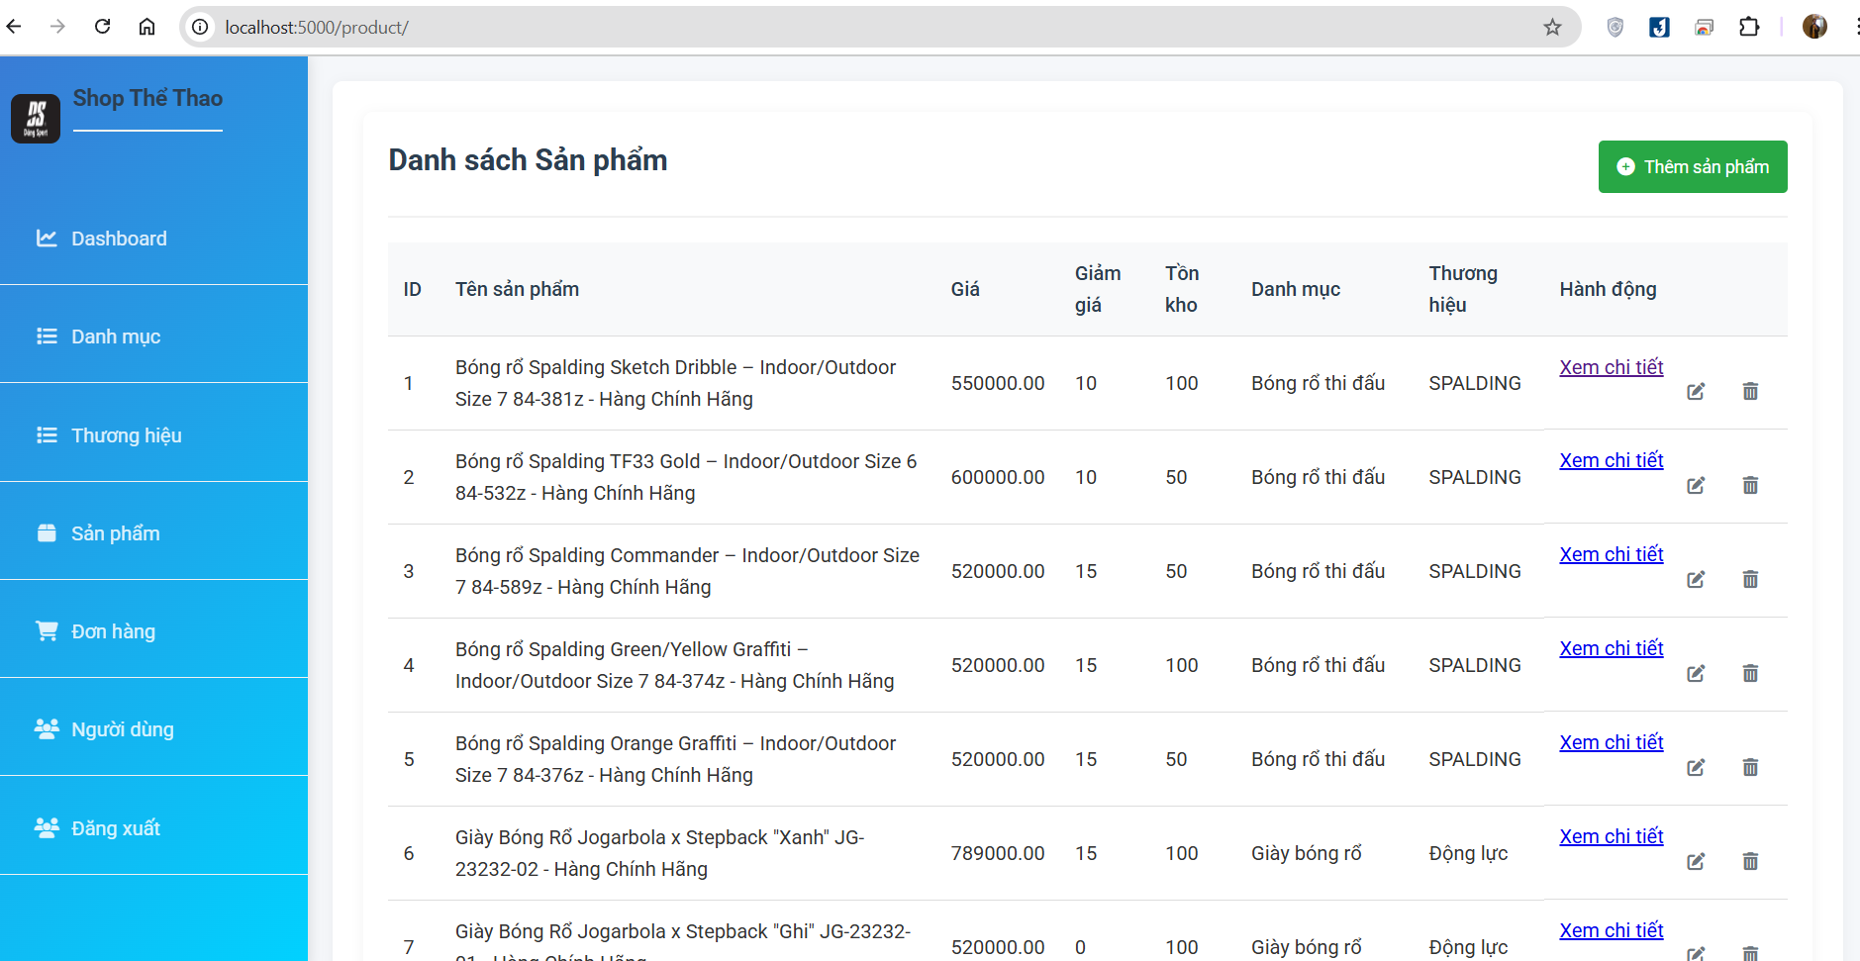

Figure 4. 23 View list product

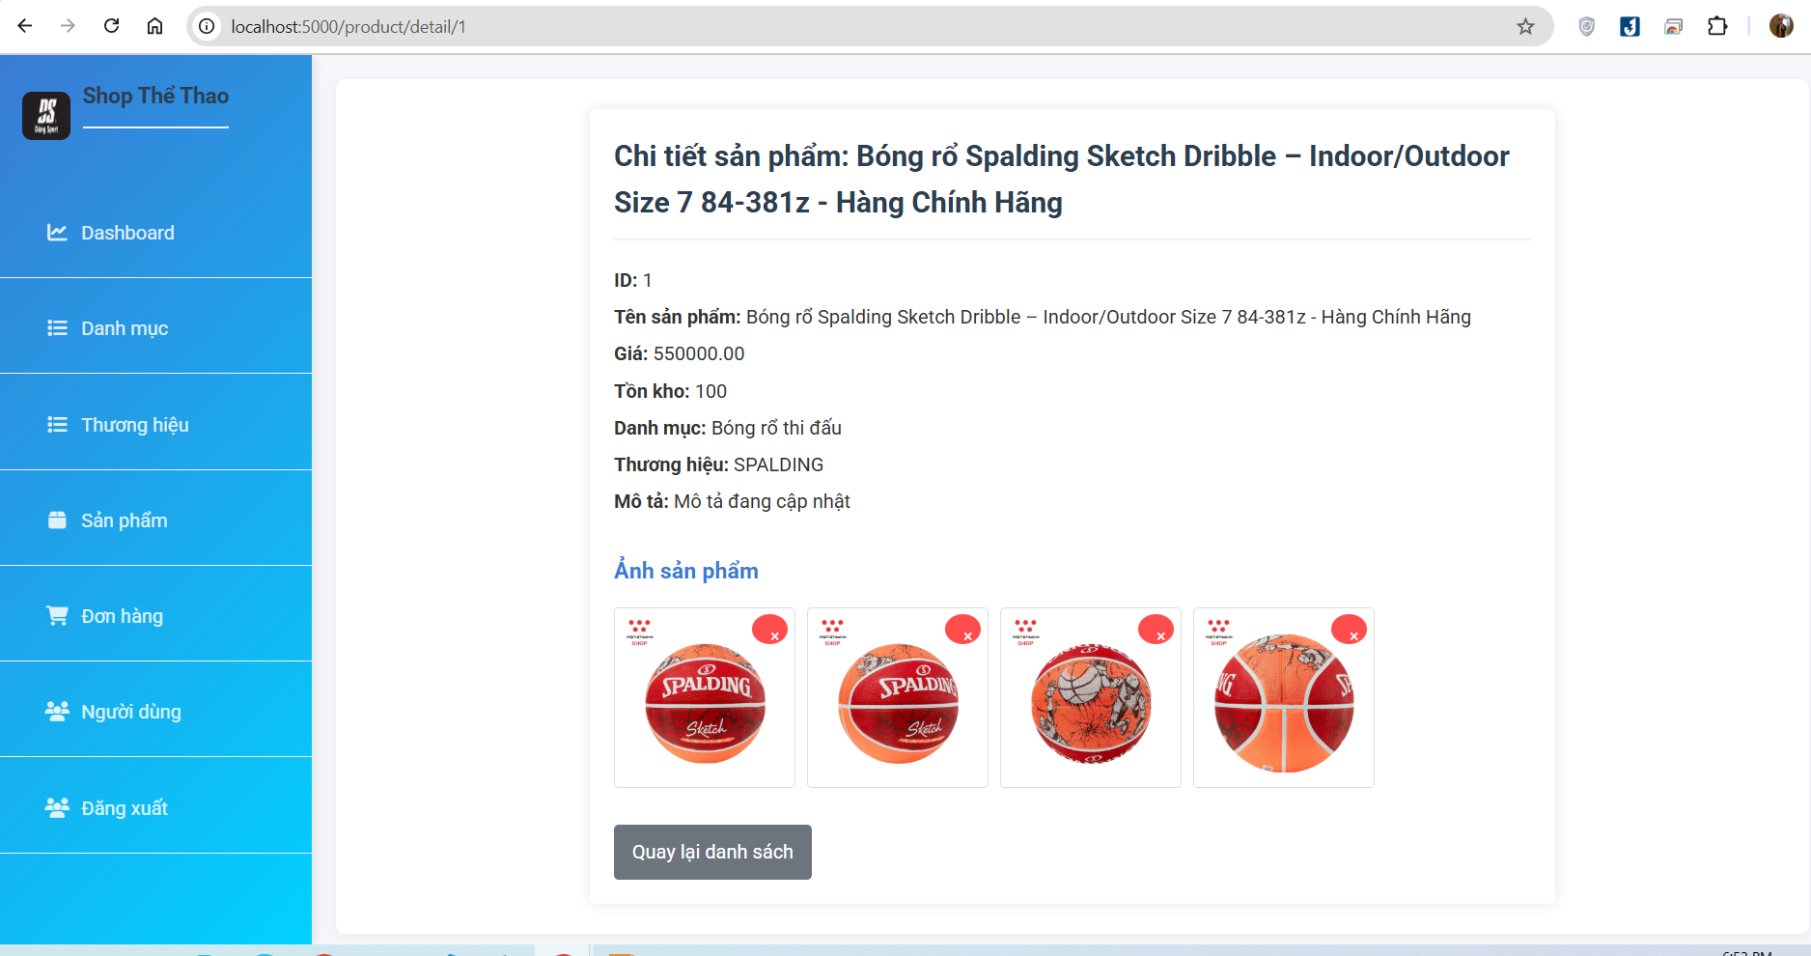

Figure 4. 24 View detail info product

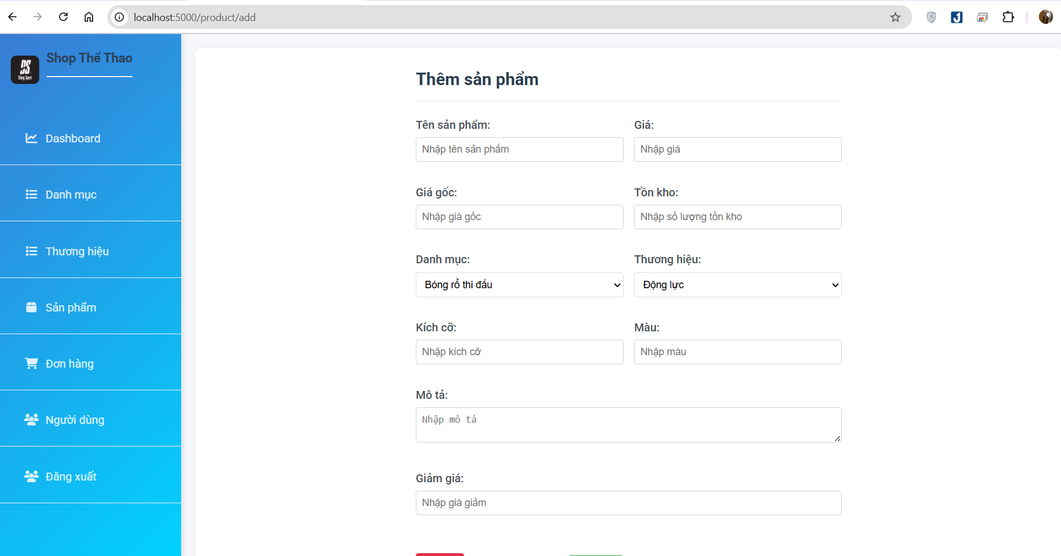

Figure 4. 25 Create new product

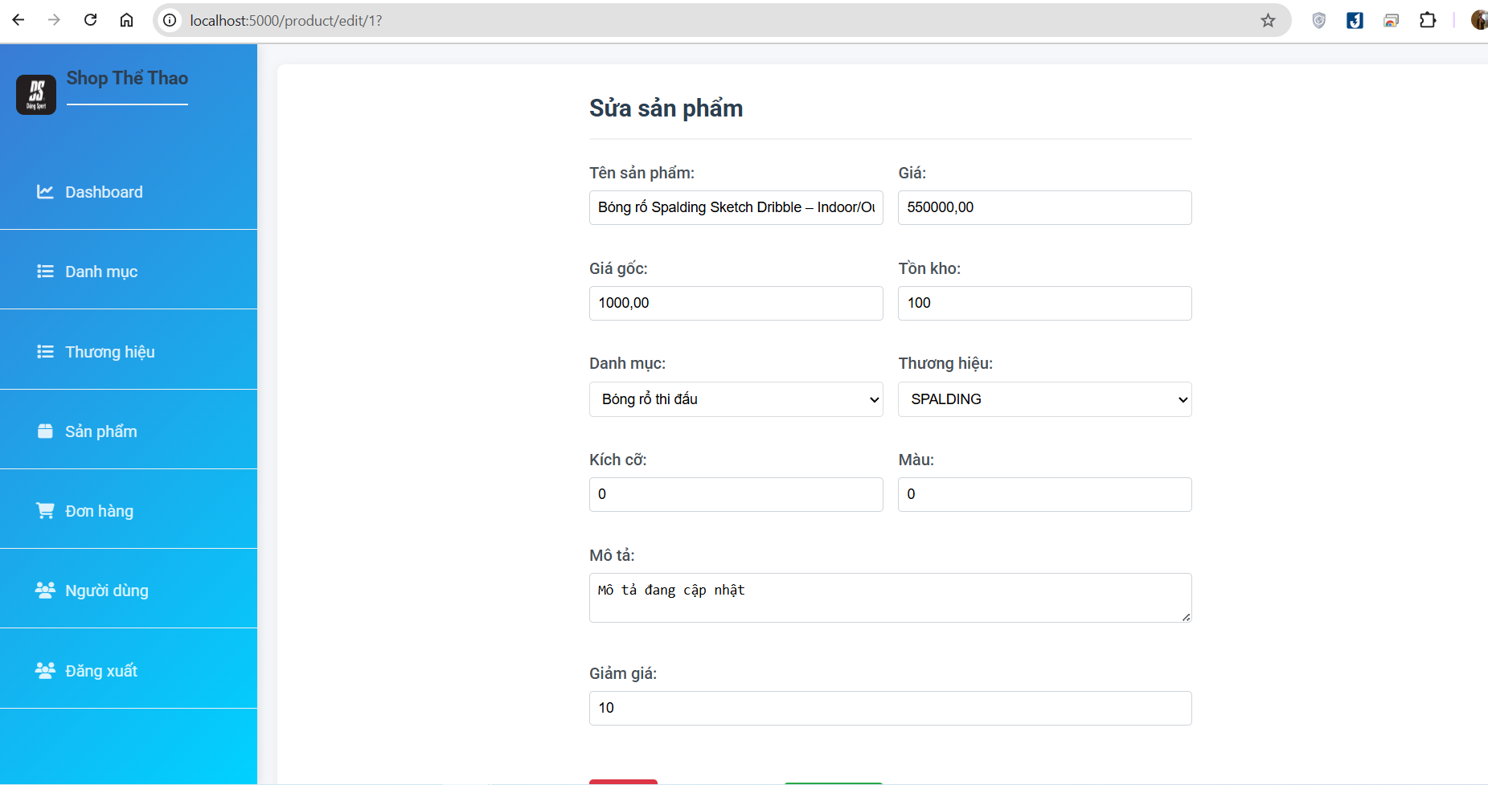

Figure 4. 26 Update information product

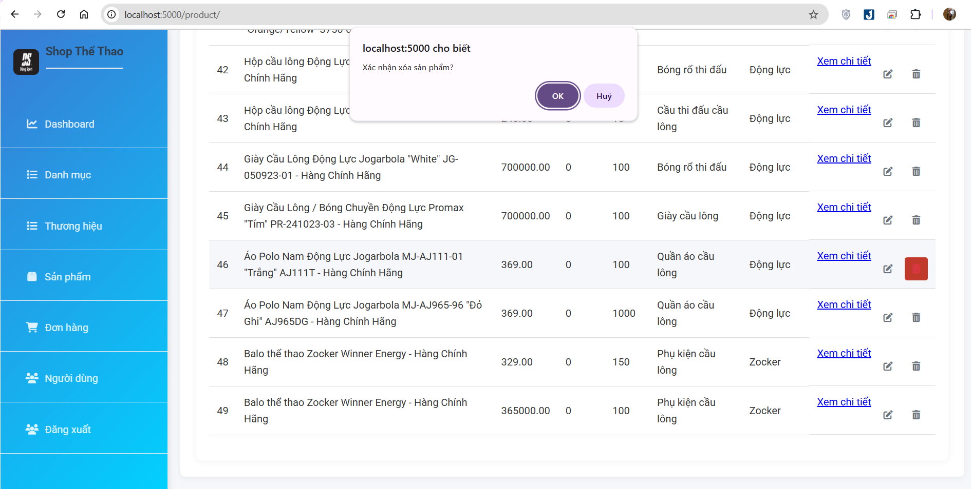

Figure 4. 27 Delete product

### **3.3.5 Order Management Page**

Figure 4. 27 Delete product

### 3.3.2.3.Search goods

Figure 3. 8: Search goods (Source: Author)

### 3.3.2.4.Payment

*Figure 3. 9: Payment (Source: Author)*

**CHAPTER 4: CONCLUSION**

In conclusion, the development of an e-commerce website for Thanh Thuy Store marks a significant step towards modernizing its retail operations and expanding its market reach. Throughout the project, we have meticulously analyzed the requirements, designed user-friendly interfaces, and implemented robust solutions to address various challenges.

By leveraging the power of e-commerce platforms, Thanh Thuy Store can now offer its products to a wider audience, provide a seamless shopping experience, and enhance customer satisfaction. The website enables customers to browse, select, and purchase products conveniently from the comfort of their homes, thereby increasing sales revenue and fostering customer loyalty.

Moreover, the implementation of features such as customer management, inventory tracking, and order processing streamlines business operations and improves efficiency. It allows Thanh Thuy Store to manage its resources more effectively, optimize inventory levels, and respond promptly to customer inquiries and feedback.

Looking ahead, continuous monitoring, evaluation, and refinement of the e-commerce website will be essential to ensure its long-term success. Regular updates, security enhancements, and adaptation to evolving market trends will help Thanh Thuy Store stay competitive in the dynamic retail landscape.

In essence, the development of the e-commerce website represents a strategic investment for Thanh Thuy Store, positioning it for sustainable growth and success in the digital era. With a strong online presence and a commitment to customer satisfaction, Thanh Thuy Store is well-equipped to thrive in the competitive retail market.

# REFERENCES

[1] K. C. Laudon and C. G. Traver, *E-commerce 2019 : business, technology, society*. Pearson, 2020. Accessed: Jun. 02, 2024. [Online]. Available: https://thuvienso.hoasen.edu.vn/handle/123456789/12556

[2] “Báo cáo Chỉ số Thương mại điện tử Việt nam 2020,” HIỆP HỘI THƯƠNG MẠI ĐIỆN TỬ VIỆT NAM. Accessed: Jun. 02, 2024. [Online]. Available: https://vecom.vn/bao-cao-chi-so-thuong-mai-dien-tu-viet-nam-2020

[3] “The Development of e Commerce in Vietnam.” Accessed: Jun. 02, 2024. [Online]. Available: https://industrial.savills.com.vn/2024/03/development-of-e-commerce-in-vietnam/

[4] “Cashless payments surge by over 63%,” vietnamnews.vn. Accessed: Jun. 02, 2024. [Online]. Available: https://vietnamnews.vn/economy/1651601/cashless-payments-surge-by-over-63.html

[5] “eCommerce - Vietnam | Statista Market Forecast,” Statista. Accessed: Jun. 02, 2024. [Online]. Available: https://www.statista.com/outlook/emo/ecommerce/vietnam

[6] T. text provides general information S. assumes no liability for the information given being complete or correct D. to varying update cycles and S. C. D. M. up-to-D. D. T. R. in the Text, “Topic: E-commerce in Vietnam,” Statista. Accessed: Jun. 02, 2024. [Online]. Available: https://www.statista.com/topics/5321/e-commerce-in-vietnam/

[7] R. Kumah, “An eCommerce shopping website.” Accessed: Jun. 02, 2024. [Online]. Available: http://www.theseus.fi/handle/10024/149293

[8] M. S. Hasan, “Web Based Application for Daily Shopping,” Thesis, East West University, 2017. Accessed: Jun. 02, 2024. [Online]. Available: http://dspace.ewubd.edu:8080/xmlui/handle/123456789/2317

[9] S. P. Singh and J. V. Deshpande, “Break-Even Point,” *Economic and Political Weekly*, vol. 17, no. 48, pp. M123–M128, 1982.

# APPENDIX

Here is the project website link : https://dungsport-store.onrender.com/